**Data Mining**

**on**

**CARDIOVASCULAR DISEASE**

INFOSYS 722

BDAS Iteration 4

Yin Yuan

yyua689

Table of Contents

Disclaimer 5

1. Business/Situation Understanding 5

1.1. Business/Situation Objectives 5

1.2. Assessing the Situation 6

1.2.1. Values of Data Mining for Heart Disease 6

1.2.2. Current Situation for CVD Data Mining 7

1.2.3. Risks and Contingencies 7

1.2.4. PySpark Environment 8

1.3 Data Mining Objectives 8

1.4 Project Plan 9

2. Data Understanding 12

2.1. Raw Data Collection 12

2.2. Data Description 12

2.3. Data Exploration 15

2.4. Data Quality Audit 18

2.4.1. Missing Values and Extreme Values 18

2.4.2. Extreme Values Explained and Feature Value (coding) Inconsistencies 19

3. Data Preparation 22

3.1. Data Selection 22

3.2. Data Cleaning 25

3.2.1. Missing value Audit 25

3.2.2. Extreme Data and Outliers 27

3.3. Constructing/Deriving a New Feature 34

3.3.1. Processing Missing Value, Extremes and Outlines 34

3.3.2. Multiple Variable Analysis and New feature created 43

3.4. Data Integration 47

3.5. Data Formatting 48

4. Data Transformation 52

4.1. Reduce the data 52

4.1.1. Reduce Feature “id” 52

4.1.2. Reduce Feature “height” and “weight” 53

4.2. Project the data 53

4.2.1. Re-formatting the data 53

4.2.2. One-Hot Encode Data Based on the Models 55

5. Data Mining Method Select 59

5.1. Match the goals to methods of data mining 59

5.2. Select the appropriate data-mining methods 60

6. Data Mining Algorithm Select 65

6.1. Exploratory of algorithms 65

6.2. Algorithm Selection 68

6.3. Build/Select Models with Algorithm/Model Parameter(s) 70

6.3.1. Discovering relationship between model and features 70

6.3.2. Parameters to evaluate model 71

7. Data Mining 73

7.1. Creating Logical Tests(s) 73

7.2. Conduction Data Mining (Running the model) 77

7.2.1. Logistical Regression 77

7.2.2. Decision Tree 79

7.2.3. Random Forest 80

7.3. Patterns Searching 81

7.3.1. Logistical Regression 81

7.3.2. Decision Tree 84

7.3.3. Random Forest 87

8. Interpretation 89

8.1. Study the mined patterns 89

8.1.1. Pattern for Logistical Regression 90

8.2. Visualizing the Data, Results, Models and Patterns 91

8.2.1. Visualizing the Data Distribution of the dataset 91

8.2.2. Visualizing the results, models, patterns 96

8.3. Interpret the Results, Models and Patterns 99

8.4. Assessing and Evaluating Results, Models and Patterns 102

8.5. Iterations 108

8.5.1. Updated chapter 4 Data Transformation 108

8.5.2. Removing Extremes, reducing features and adding new feature 108

8.5.3. Rebuild data type 109

Bibliography 113

**Disclaimer**

I acknowledge that the submitted work is my own original work in accordance with the University of Auckland guidelines and policies on academic integrity and copyright. I also acknowledge that I have appropriate permission to use the data that I have utilized in this project.

**Depository**

Codes, data set and report are available on the GitHub Depository below:

<https://github.com/yyua689/722BDAS>

1. **Business/Situation Understanding**
   1. Business/Situation Objectives

Cardiovascular disease (CVD) is the leading cause of mortality and morbidity in modern societies and encompasses a range of human pathology. It is highly suspected that CVD is strongly related to genetic and environmental factors, while studies have demonstrated that there is an interaction between genetic and environmental factors that can lead to CVD. (Papageorgiou, 2017)

CVDs are the number 1 cause of death globally: more people die annually from CVDs than from any other cause. An estimated 17.9 million people died from CVDs in 2016, representing 31% of all global deaths. Of these deaths, 85% are due to heart attack and stroke. ((WHO), 2020)

The most important risk factors of heart disease and stroke are unhealthy diet, physical inactivity, tobacco use and harmful use of alcohol. The effects of risk factors may show up in individuals as raised blood pressure, raised blood glucose, raised blood lipids, and overweight and obesity. These “intermediate risks factors” can be measured in primary care facilities and indicate an increased risk of developing a heart attack, stroke, heart failure and other complications.

There are also several underlying determinants of CVDs or "the causes of the causes". These reflect the major forces driving social, economic, and cultural change – globalization, urbanization and population ageing. Other determinants of CVDs include poverty, stress and hereditary factors.((WHO), 2020)

Hence, a study will be conducted with the following objective:

* To explore the most important features from all the mentions features by data mining from health dataset.
* To instantiate the relationships between past cardio incidents between all the factors.
* Aware of the important factors leading to CVD disease.

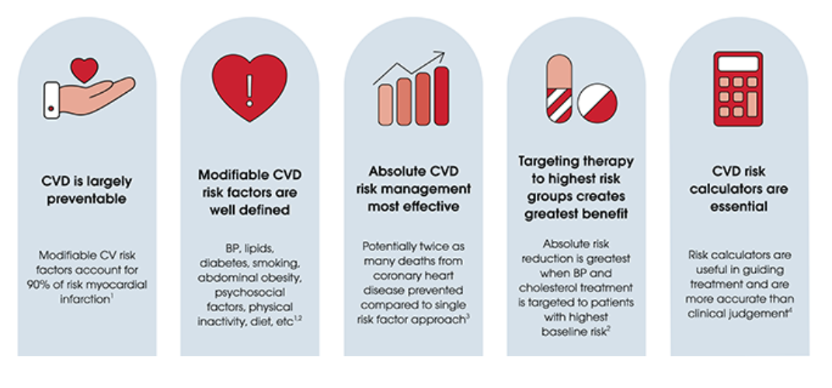

Figure 1 Absolute CVD risk principles(Foundation, 2019)

* 1. Assessing the Situation

With the development of informatization in the medical industry, a large amount of clinical medical information is generated every year, and medical data is continuously increasing explosively. Massive disease diagnosis data, clinical experiment data, and residents' behavioral health data have gathered to open the era of big data.

* + 1. Values of Data Mining for Heart Disease

The use of data mining technology to discover the potential laws of medical data and predict its development trend is especially important for disease diagnosis and treatment and medical research. Cardiovascular disease is a major problem that endangers global public health, seriously affecting the development of human physical and mental health, and accounts for about 30% of global deaths worldwide. As a common chronic cardiovascular disease, hypertension is prone to serious prognostic diseases such as stroke, heart failure and renal failure, and the onset of these diseases is related to a variety of risk factors. How to detect and effectively prevent and control these risk factors early, as well as to establish a risk warning model for the prognosis of serious disease events, is of great significance to control the onset of cardiovascular disease.

According to statistics from the World Health Organization, in 2012, the number of deaths caused by non-communicable diseases worldwide was 38 million, of which cardiovascular diseases (heart disease and stroke, etc.) accounted for 17.5 million, accounting for 46.2% of all deaths caused by non-communicable diseases. ; The fearful cancer caused 8.2 million deaths, accounting for 21.7% of all non-communicable diseases. The prevention and treatment of cardiovascular disease is indeed urgent.

* + 1. Current Situation for CVD Data Mining

In fact, scientists have been trying to find risk factors related to cardiovascular and cerebrovascular diseases in order to achieve the purpose of disease prevention. For example, the American College of Cardiology/American Heart Association (ACC/AHA) and other institutions have listed a series of factors such as high blood pressure, cholesterol, age, smoking and diabetes as related to the heart through years of research. Factors related to the high risk of vascular disease and launched the ACC/AHA prediction model.

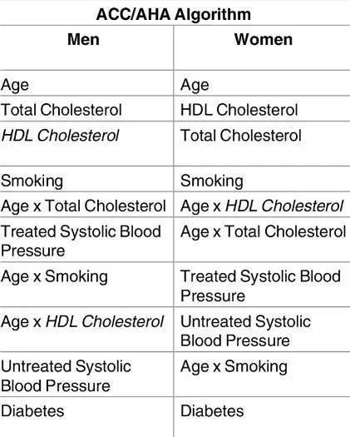

ACC/AHA's prediction of the main risk factor combination

* + 1. Risks and Contingencies

Compared with the ACC/AHA guidelines, the three risk factors of age, gender and smoking are also listed as the primary risk factors by popular machine learning algorithms. However, many current cardiovascular disease algorithms consider diabetes as one of the risk factors, and the four machine learning models either do not consider this factor or only consider glycosylated hemoglobin as a risk factor.

According to current popular machine learning and data mining models, it is considered diseases such as atrial fibrillation, ethnic differences, chronic kidney disease, chronic obstructive pulmonary disease and severe mental illness, as well as whether to take corticosteroids, and biomarkers such as triglyceride levels as important risk factors, but none of these exist in the existing model.

Based on the CVD selected all data is about 70, 000 rows representing 70, 000 patients with completely situations about whether the facts is compliant to the real situations. Furthermore, the total 13 columns reflect 12 factors as well as ID number, which could be predicted for all picture of CVD risks. Traditional data mining methods are not suitable for CVD data. However, possible risks and its corresponding contingency plan based on the dataset are identified as Programming tools familiar, data set Contingencies.

* + 1. PySpark Environment

The PySpark environment is based on AWS educate account, then log in to the AWS EC2 instance. Then using the instance summary of public IPv4 address and *.ppk to access putty to PySpark jupyter notebook.

* 1. Data Mining Objectives

The data mining goals of this study are:

* Use the data mining methods for CVD risks prediction to find out the key factors influence the probabilities.
* Once key features found, based on the important features to build several data mining models with corresponding analysis.
* Through analysis, see section 8 interpretation about the feature discovering for CVD risks.
* In the future, different data mining methods or multiple data mining analyzing methods will be implemented to reveal more factors

In this study, four different data mining modelling methods, feature selection, logistic regression, random forest, and neural network, will be implemented. In terms of computation complexity, logistical regression model is much more preferred in machine learning or statistical analysis. Neural network contributes the most complexity. In terms of computation, random forest cost longest time about 37 sec compared to neural network 14 sec shortest processing time. In terms of assessing the accuracy, random forest contributes the highest accuracy based on the given data set.

* 1. Project Plan

This iteration is about PySpark implantation, manipulation, practice, data mining via PySark Tools. PySpark is the Python API written in python to support Apache Spark. Apache Spark is a distributed framework that can handle Big Data analysis. [Apache Spark](https://www.gangboard.com/blog/what-is-apache-spark/) is written in Scala and can be integrated with Python, Scala, Java, R, SQL languages. Spark is basically a computational engine, that works with huge sets of data by processing them in parallel and batch systems. A simple project plan outlining the major tasks in this project in shown in Table 2. We provide a work breakdown structure (WBS) and a Gantt chart in Table 2 to illustrate the dedicated time for each specific task and the iterations among the steps (step 1-8).

**Gantt chart Project TimeLine**

The overview plan for the study is as shown in the chart below.

Figure 2 Gantt Chart for BDAS Project TimeLine

Despite Gantt Chart BDAS Timeline, all the work was breakdown according to the different tasks as shown in Table 2. The most consuming work was spent on familiar PySpark environment, data mining, pattern searching, and interpretation to get a whole picture of data mining work based on PySpark environment

**Workload and Resource Arrangement**

|  |  |  |  |
| --- | --- | --- | --- |
| **Phase** | **Time** | **Resources** | **Comments** |
| Business Understanding | 1 | Website, Survey | Re-reading with  adjustment if existed |
| Data Understanding | 6 | Python, PySpark | Familiar with PySpark Environment |
| Data Preparation | 2 | PySpark | Data operation and preparation |
| Data Transformation | 2 | PySpark | Learning Data Manipulation |
| Data Mining Method Select | 1 | Methods Searching, PySpark | Effectiveness evaluation, adjusted if the method is not work out in PySpark Environment |
| Data Mining Algorithm Select | 2 | Algorithms Tradeoff, PySpark | Algorithms Selections |
| Data Mining | 2 | PySpark | Performance Evaluation based on built models |
| Interpretation | 4 | PySpark | Pattern Studies and Visualization when there is necessary to go iterative updates |
| Total | 21 | | |

Table 1 BDAS Project Plan WBS

1. **Data Understanding**
   1. Raw Data Collection

Resource Inventory All hardware and software are used following InfoSyS722 tutorial and lab instructions, as system processor Intel i7 1.8 GHz and RAM 16 GB as hardware and windows 10 education version.

Medical data is confidential and not too much data is available for public or with open source. The raw data was collected from Kaggle the Machine Learning and Data Science Community by input key words searching: Cardiovascular Disease.

The results return 273 results: Comments 136, Notebook 73, Topics 33, Datasets 31.

The dataset was selected is listed below, which needs an account to log in and download.

[https://www.kaggle.com/sulianova/cardiovascular-disease-dataset#](https://www.kaggle.com/sulianova/cardiovascular-disease-dataset)

Down load zip file is 743KB unzipped to cardio_train.csv shown in excel file -> The cardio_train.csv file is roughly raw which needs transformed and preprocessed to get the data format.

In terms of data quality assumptions the results of medical examination; information given by the patient; data is aggregated data with csv format; It is also believed that all data are independent from each other as independent patient, so that the result of data mining will be predicted based on the data set given in 1.2.1 section.

* 1. Data Description

The dataset is created 2 years ago consists of 70,000 records of patient’s data in 12 features,

as 1 Age, 2 Height, 3 Weight, 4 Gender, 5 Systolic Blood Pressure, 6 Diastolic Blood Pressure, 7 Cholesterol, 8 Glucose, 9 Smoking, 10 Alcohol intake, 11 Physical activity, 12 Presence or Absence of cardiovascular disease and one more field for ID number.

The target of data mining for CVD is 12 cardiovascular disease: 0 for health, 1 for the patient has CVD disease.

**Data Type Description of Input Variables**

Input data could be described as three types: 1) Objective Information which is factual information; 2) Examination Information the results were given by medical examination; 3) Subjective information was given by patients.

**Detailed Description**

All the 12 fields were given below by fields, input data type, labeled name in dataset and measure unit and field 0 is record ID number. Target filed is 12 Presence or absence of cardiovascular disease.

|  |  |  |  |  |
| --- | --- | --- | --- | --- |
| Fields | Input Data Type | Input Type | Name in Dataset | Unit in Measure |
| 0 | ID number |  |  |  |
| 1 | Age | Objective Feature | age | int (days original needs to be converted) |
| 2 | Height | Objective Feature | height | int (cm) |
| 3 | Weight | Objective Feature | weight | float (kg) |
| 4 | Gender | Objective Feature | gender | categorical code: 1 - women,  2 - men |
| 5 | Systolic blood pressure | Examination Feature | ap_hi | int |
| 6 | Diastolic blood pressure | Examination Feature | ap_lo | int |
| 7 | Cholesterol | Examination Feature | cholesterol | 1: normal,  2: above normal, 3: well above normal |
| 8 | Glucose | Examination Feature | gluc | 1: normal,  2: above normal, 3: well above normal |
| 9 | Smoking | Subjective Feature | smoke | binary |
| 10 | Alcohol intake | Subjective Feature | alco | binary |
| 11 | Physical activity | Subjective Feature | active | binary |
| 12 | Presence or absence  of cardiovascular disease | **Target Variable** | cardio | binary |

Table 3 Data Description in Detail

**Detailed Description by PySpark**

Import data set csv data into PySpark by findspark. Then read data as `df`, show the data set.

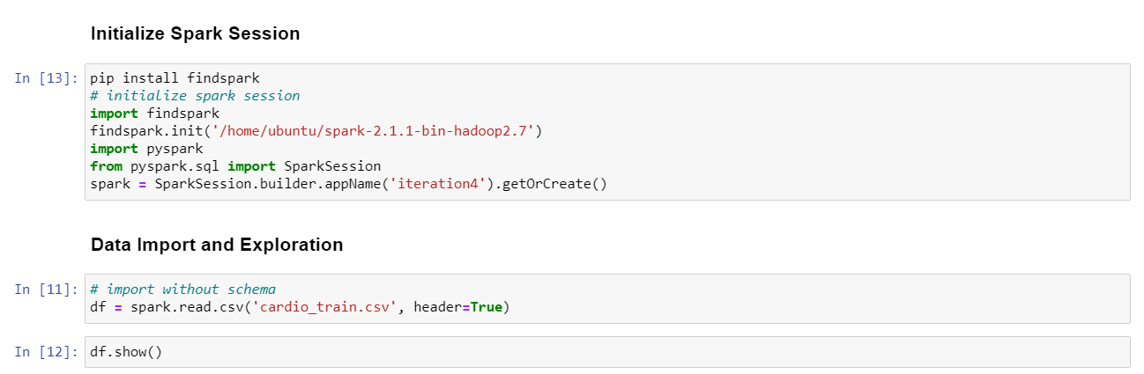

Figure 3 Read cadio.csv data into PySpark

Import data set csv data into PySpark by findspark. Then read data as `df`, show the data set. The following chart shows the detailed information about the `cardio` dataset. More information about the dataset will be explored in the following section.

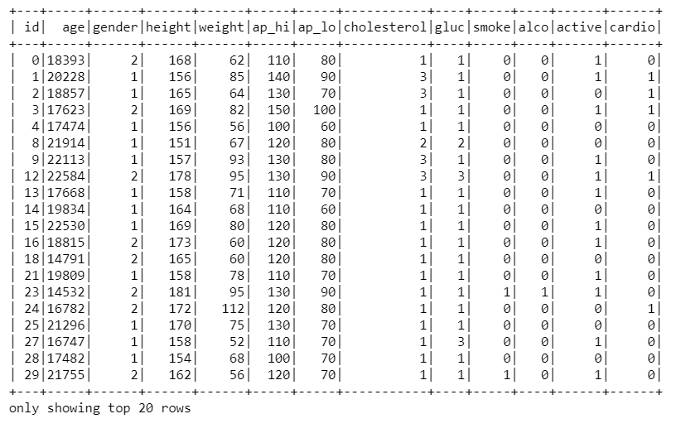

More detailed information about data set is shown in `df.describe().show()`, which give the information of 70000 rows with mean, min, max information about each variable.

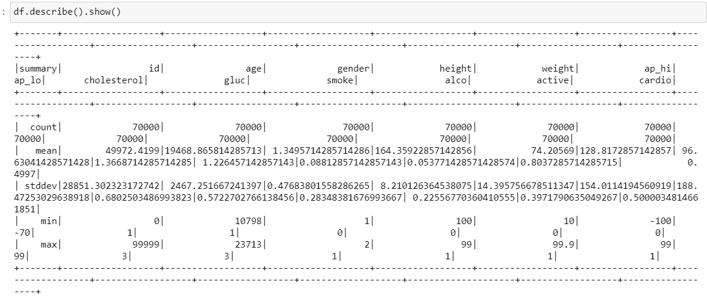

Showing more information about the dataset by *df.columns*

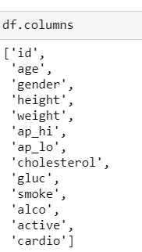

* 1. Data Exploration

By getting the exploration from PySpark to Pandas, it takes command `df.toPandas` transform PySpark data frame `df` to Pythond library Pandas format treated as `data`. Then print out the data to find insight when transform PySpark format to Python format.

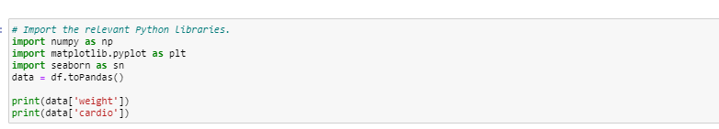

Taken an insight of the `data` format in Python based on PySpark notebook platform.

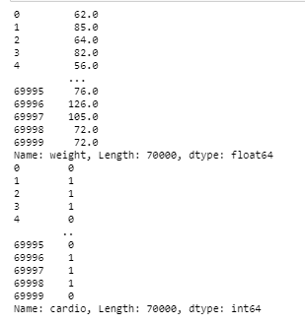

Then the system imported library `matplotlib` and `seaborn` as exploration tools to find more information about features and correlations.

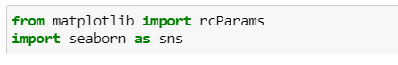

Age is measured by unit (days), height is by unit (centimeters), by looking insight of target variable compared with age as a predicted relationship between two variables.

The result shows age as x axis, cardio situation as y axis. The cardio are calculated in green and red represented as Health and with “Cardio” records.

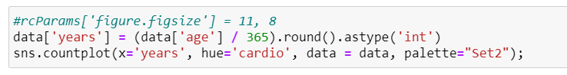

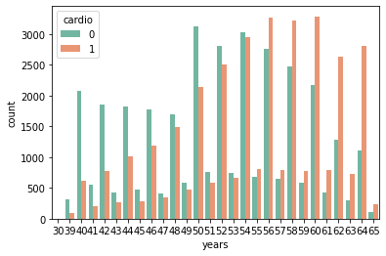

Figure 4 Correlation between years and cardio

It can observe that when people aged above 55 with much higher probability to expose to CVD. From Table 5, the outliers are shown as 4 variables of ap_hi, ap_lo, weight and height. The outliers will be deal with in the following sections.

To find deep understanding about the target variable: cardio with categorical variables:

Cholesterol (1: normal, 2: above normal, 3: well above normal), Glucose (1: normal, 2: above normal, 3: well above normal), Smoking(binary: 0, 1), Alcohol intake(binary: 0, 1), Physical activity (binary: 0, 1). In the figure below, the cholesterol and gluc have three types indicating 1: normal, 2: above normal, 3: well above normal; while smoke, alco, active have binary input 0 for no, 1 for yes.

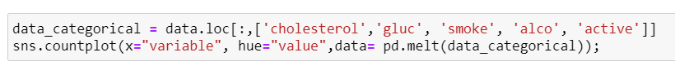

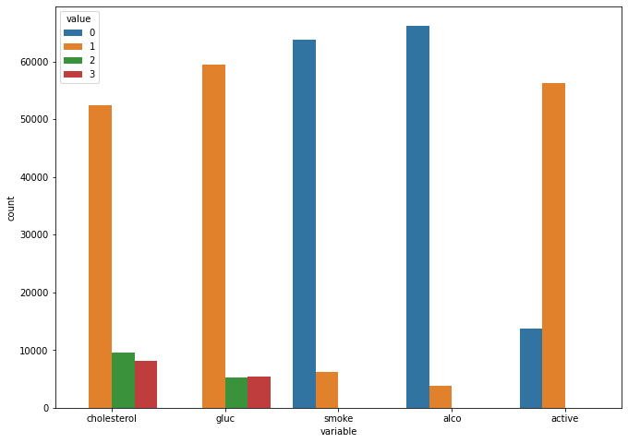

Figure 5 Categorical Variables Distribution

In dataset in Figure 6 Categorical Variables Distribution for 70,000 Records shows five categorical variables with their distribution with value 0, 1, 2, 3. In the figure, cholesterol, gluc are with three numbers in 1, 2, 3, representing 1: normal, 2: above normal, 3: well above normal. In Figure 7, there are more than 50,000 records are health people, and about than 10,000 with distribution.

By comparison distribution, table and audit, further steps will focus on data preparation about several steps to get more convergence data of step 3.

Some initial hypothesis deferring to be association in data mining from the raw data to be connect with the target as followings. In the followings chapters, the actual data mining results could be found in

* There is a relationship between
  + Assumption input data: age with target cardio
* There is a relationship between
  + Assumption input data: input smoke with target cardio
* There is a relationship between
  + Assumption input data: alcohol with target cardio
* There is a relationship between
  + Assumption input data: ap_hi and ap_lo both with target cardio

There are some actions that could be taken to find inner relationships between features via Cross Tabulation ‘’

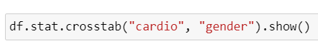

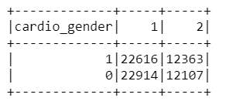

* 1. Data Quality Audit
     1. Missing Values and Extreme Values

Exploration null values in PySpark with *df.printSchema()* to check more information about the dataset from Python perspective with number of entries, data types and memory usage.

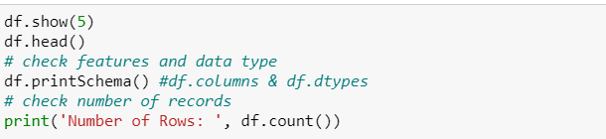

Command `df.show()` and `df.head()` show the basic information of the `cardio_train` data set from PySpark point of view.

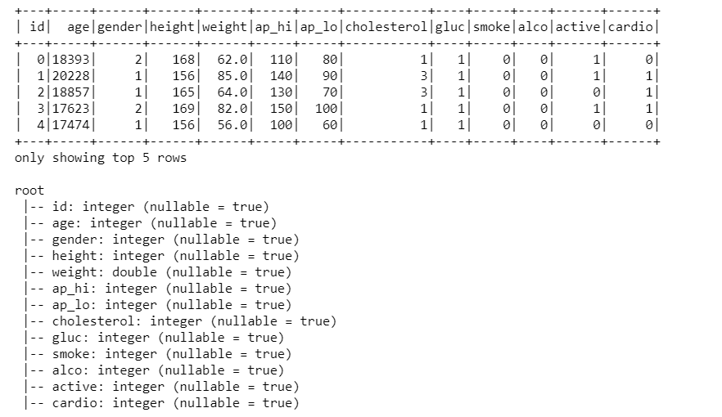

Figure 8 Null values Information about Dataset

From figure 5, all variables are string type with non-Null values. This column shows the completement of variables with non-null values.

* + 1. Extreme Values Explained and Feature Value (coding) Inconsistencies

With further exploration in data audits by set a target data , selecting a data set, or focusing on a subset of variables or data samples, on which discovery is to be performed. (Fayyad, Piatetsky-Shapiro, & Smyth, 1996) By command describe() to display sample statistics for each attribute, such as minimum, maximum, average, and standard deviation:

|  |  |  |  |  |  |  |  |
| --- | --- | --- | --- | --- | --- | --- | --- |
| count | mean | std | min | max | 25% | 50% | 75% |
| 70000 | 49972.4199 | 28851.30232 | 0 | 99999 | 25006.75 | 50001.5 | 74889.25 |
| 70000 | 19468.86581 | 2467.251667 | 10798 | 23713 | 17664 | 19703 | 21327 |
| 70000 | 1.349571 | 0.476838 | 1 | 2 | 1 | 1 | 2 |
| 70000 | 164.359229 | 8.210126 | 55 | 250 | 159 | 165 | 170 |
| 70000 | 74.20569 | 14.395757 | 10 | 200 | 65 | 72 | 82 |
| 70000 | 128.817286 | 154.011419 | -150 | 16020 | 120 | 120 | 140 |
| 70000 | 96.630414 | 188.47253 | -70 | 11000 | 80 | 80 | 90 |
| 70000 | 1.366871 | 0.68025 | 1 | 3 | 1 | 1 | 2 |
| 70000 | 1.226457 | 0.57227 | 1 | 3 | 1 | 1 | 1 |
| 70000 | 0.088129 | 0.283484 | 0 | 1 | 0 | 0 | 0 |
| 70000 | 0.053771 | 0.225568 | 0 | 1 | 0 | 0 | 0 |
| 70000 | 0.803729 | 0.397179 | 0 | 1 | 1 | 1 | 1 |
| 70000 | 0.4997 | 0.500003 | 0 | 1 | 0 | 0 | 1 |

Table 4 Describing Statistic Sampling

Using PySpark to explore more information about data set from PySpark Point of view.



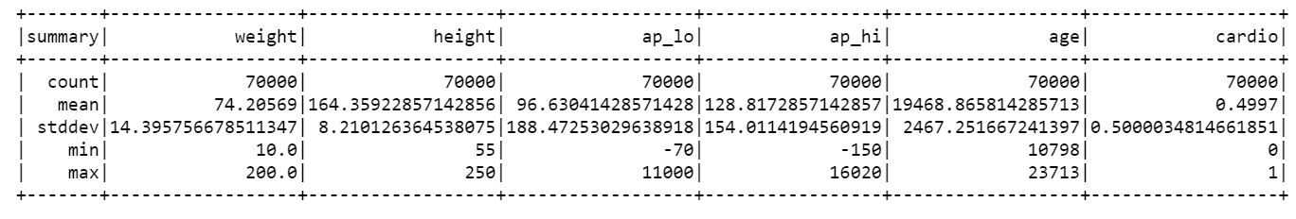

Figure 9 Audit Information for Selected Features

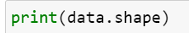

Getting information from Python code about the data set from Python view

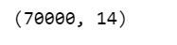

Getting information about gender and class type of gender.

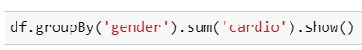

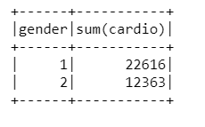

Getting information of feature `cardio` and `gender` to find the data is quit equally distributed.



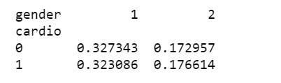

From the result shown above, the gender distribution is fairly equal. Then to find the missing value from Python view:

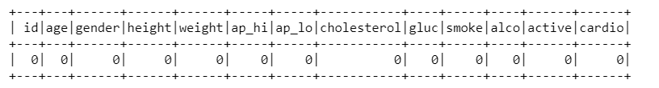

The result shows no missing value within the data set, which is same as `df.printSchema()` .

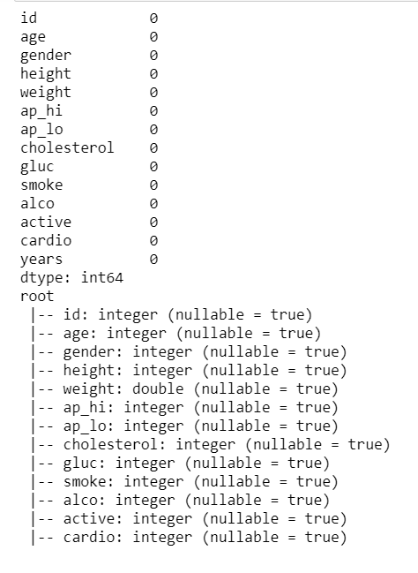

1. **Data Preparation**

From (Fayyad et al., 1996), the information about data preparation is understanding and reading the business environment and overall data in the first two chapters, you have a basic understanding of the data. This chapter will further preprocess the data, select, clean, rebuild and integrate, and have found what is needed for data mining Data type and format. This process is very time-consuming and requires great patience to process, but it is indeed a necessary step for data mining. It can be seen that this database has no missing values, but there are many extreme values and outliers, so the data set itself needs to be preprocessed, and the processed data can be further data mining and data modeling. If we use the wrong data set and incorrect data, the mining model will be unsatisfactory. Therefore, in order to build a data model close to the real data, we need to perform data cleaning and data processing to form data that meets the type of machine learning. After step 1 and step 2 currently, the understanding of raw data has convergence to select data, data cleaning, data construction, and data format.

* 1. Data Selection

After preliminary analysis of the data, data understanding and understanding of the database variables, further feature selection, cleaning, and reconstruction of the data are performed. The database has a total of 13 variables, of which we are going to be cardio as the target variable, and the 0 variable ID number is considered a variable. During the whole discussion, we plan to discuss the relationship between 11 variables and the target variable. In the process of data selection, further understand the insight of each variable, and obtain an intuitive relationship between each variable and the target variable. Find a qualitative understanding of the relationship between the target variable and each variable.

**Bivariate analysis**

Classification of binary variables according to target variable may help to filter and identify data.

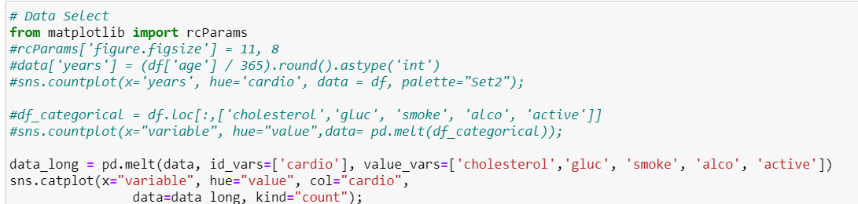

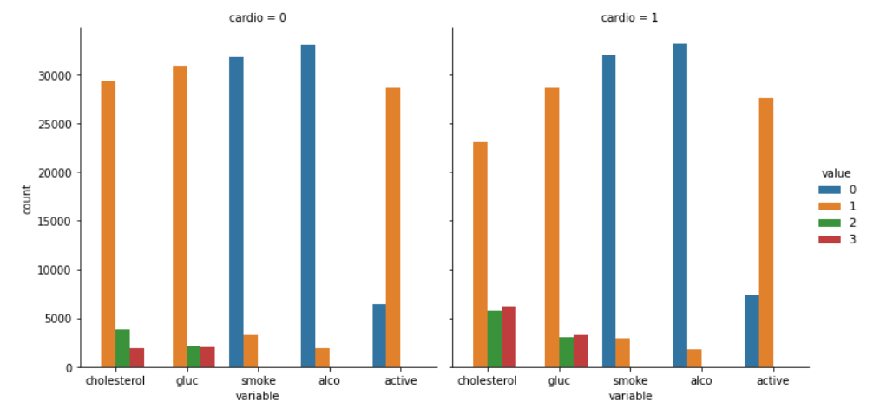

Figure 10 Based on Target Variable to find the correlation with Binary Variables

Cardio is 0 for the left picture, and cardio is 1 for the right picture. Classified by target variable, it can be seen from the figure that whether you have a heart disease is directly proportional to the index of cholesterol and is inversely proportional to whether you exercise. In other words, from the picture, the higher the cholesterol, the easier it is to get cardio disease, and the less exercise the easier it is to get cardio.

At the same time, calculate the average height in the database. Classified by gender, 1 is female, 2 is male. Roughly, the average height of female is 161 and male is 170 separately.

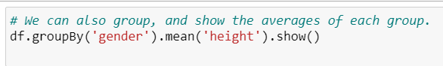

Getting information about height based on genders and data type of feature `height`.

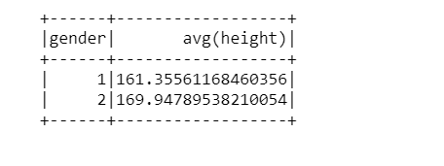

Figure 11 Data Audit

As well as audit for total number of records classed by gender:

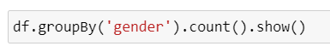

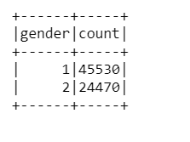

Figure 12 Number of Records by Gender

Classification based on gender, which gender is more inclined to drink

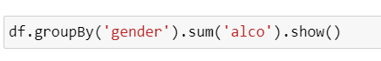

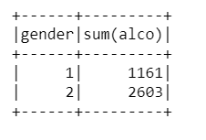

Figure 13 Alcohol intention

Compared to 1161, 2603 males are more likely to drink alcohol in this dataset. Similarity, based on the target “cardio” variable, classification is separated, 0 means no “cardio” record; 1 is means having “cardio” records. The dataset is apparent equally.

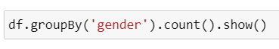

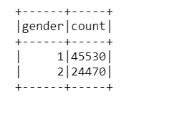

Figure 14 Target Variable Distribution

Find how the distribution occurs, and the relation between target variable and gender (still as an example)



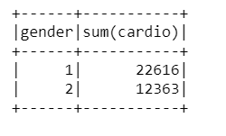

Figure 15 Relation between Gender and Target Variable

* 1. Data Cleaning
     1. Missing value Audit

From ISAS iteration 2, higher outliers will not suitable for “Screening models can be used to screen data to locate fields and records that are most likely to be of interest in modeling and identify outliers that may not fit known patterns. Available methods include feature selection and anomaly detection.” (Corporation, 2018)

Based on the missing value processing perspective and information in ISAS iteration2, missing value has much impact to data mining. By audit the value of whole dataset, this step could find missing values. Missing value will totally influence the result and pattern mined in the following result.

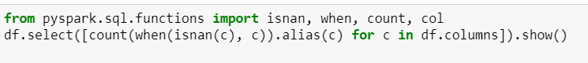

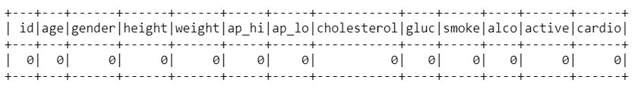

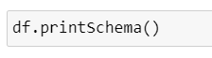

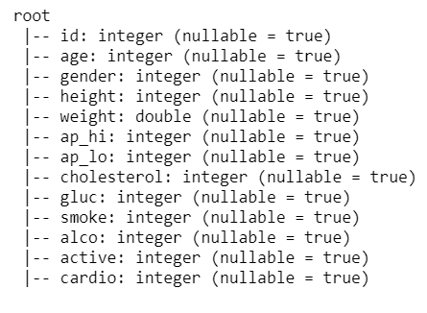

Figure 16 Counting Missing Value for each variable

Luckily, there is no missing value in this dataset. However, many existing industrial and research data sets contain missing values. They were introduced for various reasons (for example, manual data entry procedures, equipment errors, and incorrect measurement results). Therefore, the missing data is usually found in most of the information sources used. In most cases, it is easy to detect incomplete data by looking for Null values in the data set. However, this is not always the case, because missing values (MVs) may appear in the form of outliers or erroneous data (that is, out of bounds).

Missing values make it difficult for analysts to perform data analysis. Three types of problems are usually associated with missing loss of efficiency; values (referrer:J. Barnard, X.L. Meng. Applications of multiple imputation in medical studies: From AIDS to NHANES. Stat. Methods Med. Res., 8 (1) (1999) 17-36, [doi: 10.1191/096228099666230705](http://dx.doi.org/10.1191/096228099666230705) ) complications in handling and analyzing the data; bias resulting from differences between missing and complete data. On the other hand, it is important to categorize the mechanisms which lead to the introduction of MVs (R.J. Little and D.B. Rubin. Statistical analysis with Missing Data. John Wiley and Sons, New York, 1987). Such mechanism will determine which imputation method could be applied, if any. As Little and Rubin stated, there exist three different mechanism of missing data induction.

Typically, procedure to process missing value could base on the type of missing value, which is originally derived from three different factors to generate missing values.

1. Missing completely at random (MCAR), when the distribution of an example having a missing value for an attribute does not depend on either the observed data or the missing data.
2. Missing at random (MAR), when the distribution of an example having a missing value for an attribute depends on the observed data but does not depend on the missing data.
3. Not missing at random (NMAR), when the distribution of an example having a missing value for an attribute depends on the missing values.

How to deal with the real missing value? The practical approaches will be discussed in detail with more description in section 3.3 deriving and construct a new feature.

* + 1. Extreme Data and Outliers

Multiple steps have been applied into adjust the outliers and extremes.

**Outlier Definition**

The outlier is a piece of data about the abnormal distance from other points. In other words, the data is outside the other values in the collection. If you have Pinocchio in a group of children, his nose is longer than other children.

In this set of random numbers, 1 and 201 are outliers:

1,99,100,101,103,109,110,201 "1" is an extremely low value, and "201" is an extremely high value.

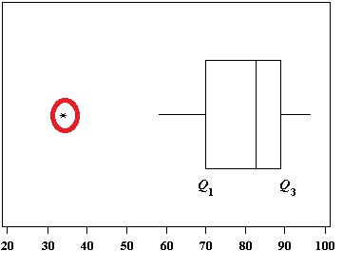

Outliers are a simple concept—they are values that are notably different from other data points, and they can cause problems in statistical procedures.

To demonstrate how much a single outlier can affect the results, the next step is to examine the properties of an example dataset. It contains 15 height measurements of human males. One of those values is an outlier. The table below shows the mean height and standard deviation with and without the outlier.

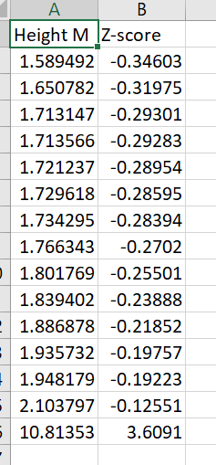

Figure 17 Sample of outliers finding

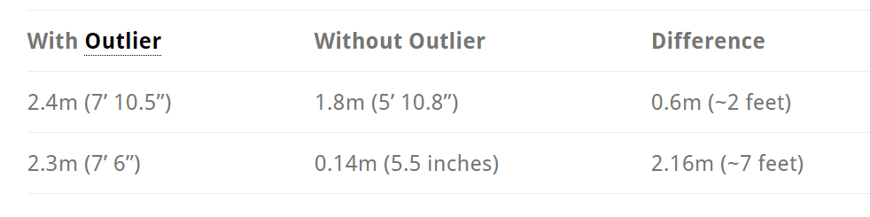

Figure 18 Outliers in Sample

From the table, it is easy to see how an outlier distorts reality. A single value will change the average altitude by 0.6m (2 feet) and the standard deviation to 2.16m (7 feet)! Hypothesis testing using means and outliers is not feasible. Moreover, a larger standard deviation will seriously reduce statistical power.

**Several methods to find outliers**

* 1. Sorting the Datasheet to Find Outliers for the sample dataset

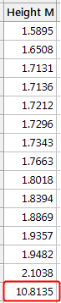

Figure 19 Finding outliers by sorting the data

* 1. Graphing the Data to Identify Outliers: Boxplots, histograms, and scatterplots can highlight outliers:

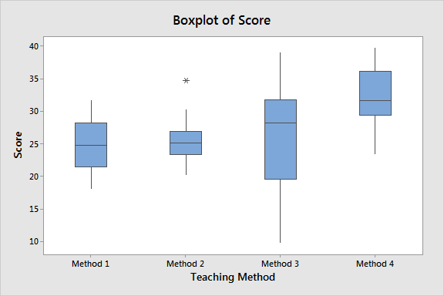

Figure 20 Finding outliers by boxing

* 1. Using Z-scores to Detect Outliers: The following probability distribution shows the distribution of Z-scores in the standard normal distribution. The Z score of more than +/- 3 is so high that you can barely see the shadow under the curve.

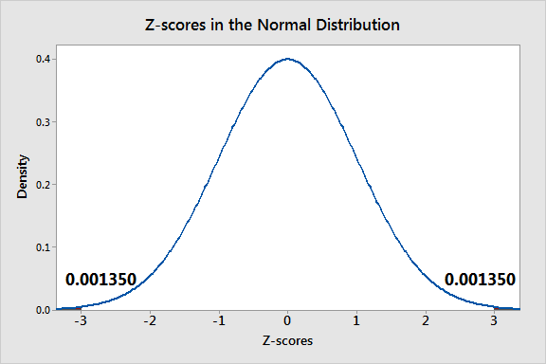

Figure 21 Z-scores finding outliers

* 1. Finding Outliers with Hypothesis Tests

To calculate the Z-score for an observation, take the raw measurement, subtract the mean, and divide by the standard deviation. Mathematically, the formula for that process is the following:

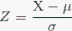

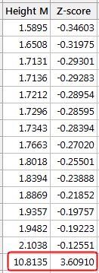

Many outlier tests exist, but in this paper, discussion mainly focus on one to illustrate how they work. In this post, Grubbs’ test will be demonstrated, which tests the following hypotheses:

Null: All values in the sample were drawn from a single population that follows the same normal distribution.

Alternative: One value in the sample was not drawn from the same normally distributed population as the other values.

If the p-value for this test is less than your significance level, you can reject the null and conclude that one of the values is an outlier. The analysis identifies the value in question.

By performing this hypothesis test using our sample dataset. Grubbs’ test assumes your data are drawn from a normally distributed population, and it can detect only one outlier. If you suspect you have additional outliers, use a different test.

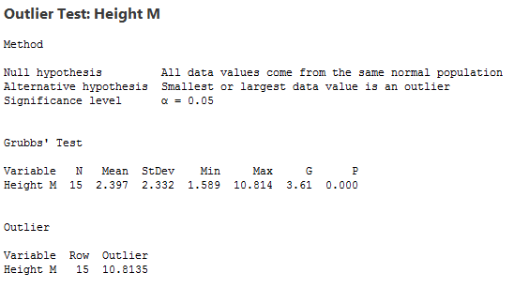

Figure 22 Outliers for sample data

**Extremes**

Extreme are different with outliers. For example, in high school, students learn the famous 68-95-99.7 rule, which is a way to remember that 99.7 percent of random observation from a normal distribution are within three standard deviations from the mean. For the standard normal distribution, the probability that a random value is bigger than 3 is 0.0013. The probability that a random value is bigger than 4 is even smaller: about 0.00003 or 3 x 10-5.

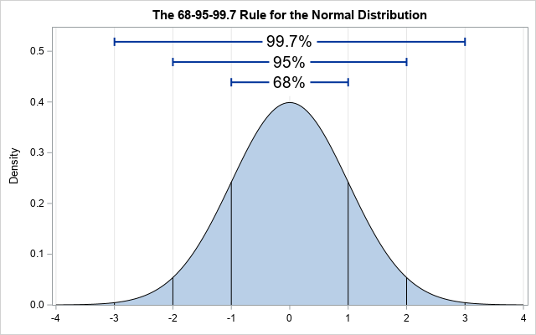

Figure 23 The 68-95-99.7 Rule

Take a Gaussian as a sample:

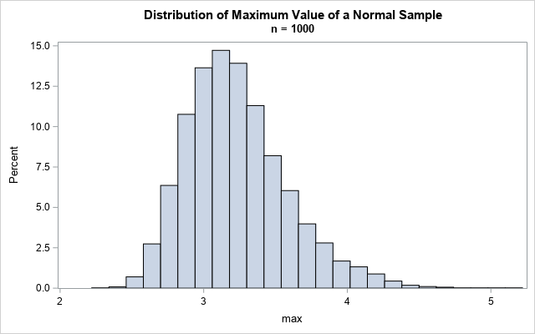

Figure 24 Gaussian Distribution

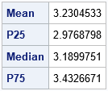

Figure 25 Processing Gaussian Data

Based on this simulation, the expected maximum value of a sample of size n = 1,000 is about 3.2. The table indicates that about 25% of the samples have a maximum value that is less than 3. About half have a maximum value less than 3.2. About 75% of the samples have a maximum value that is less than 3.4. The graph shows the distribution of maxima in these samples. The maximum value of a sample ranged from 2.3 to 5.2.

* 1. Constructing/Deriving a New Feature
     1. Processing Missing Value, Extremes and Outlines

**Finding Missing Value**

In previous analysis in section 3.2, the missing value is NULL for the dataset provided. Double check and confirm in this section with another method/code to evaluate and verify to the original dataset used in this iteration. Is there existing NA or missing value in the provide dataset?



The result for finding missing value is returned as FALSE to confirm the programming result in previous section.

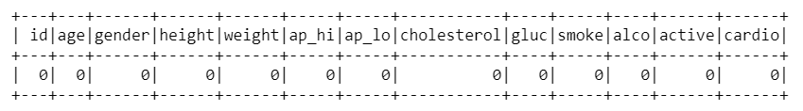

Figure 26 Verification of the Missing Value

Also, there is method to count different scenarios for different variables.

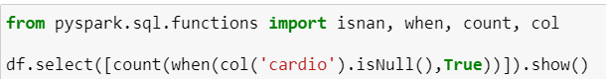

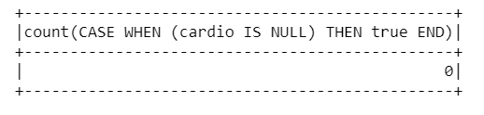

Figure 27 Missing Value for Target Cardio

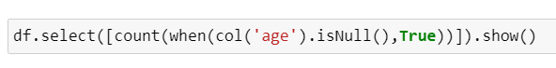

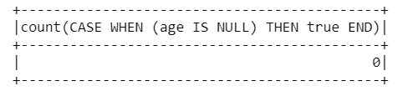

Figure 28 Missing Value for Age

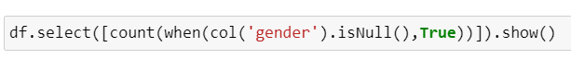

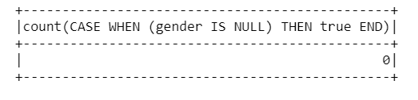

Figure 29 Missing Value for Gender

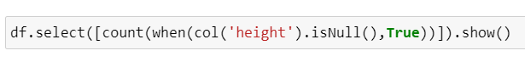

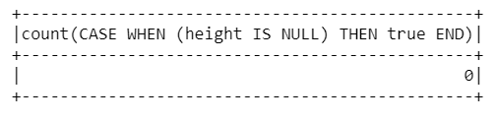

Figure 30 Missing Value for Height



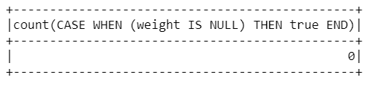

Figure 31 Missing Value for weight



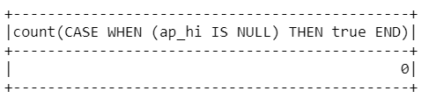

Figure 32 Missing Value for 'ap_hi'

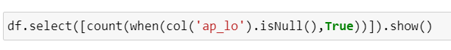

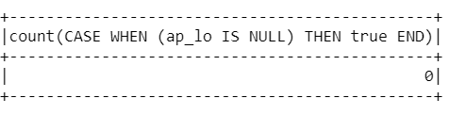

Figure 33 Missing Value for 'ap_lo'

In this dataset, it does not have the missing value to deal with for it is tidy and clean in Kaggle website. However, the missing value is indeed existed in real. Thus, methods to handle the real problem is required and essential. The following is to find how to process Method to deal with missing value from a practice and efficient way.

1. Do Nothing:

That is an easy one. You just let the algorithm handle the missing data. Some algorithms can factor in the missing values and learn the best imputation values for the missing data based on the training loss reduction (ie. XGBoost).

1. Imputation Using (Mean/Median) Values:

This works by calculating the mean/median of the non-missing values in a column and then replacing the missing values within each column separately and independently from the others. It can only be used with numeric data.

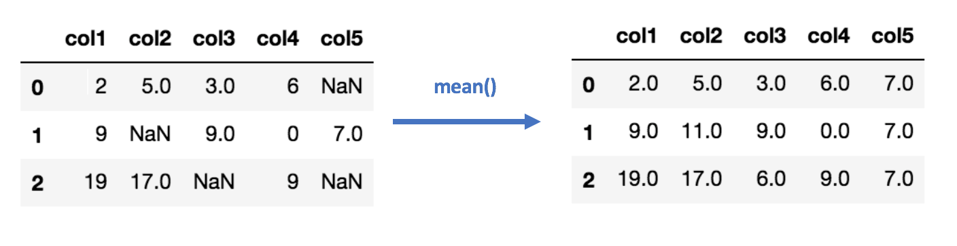

Figure 34 Imputation mean or median for missing value

1. Imputation Using (Most Frequent) or (Zero/Constant) Values:

Based on the audit of figure 8, the situation changed to height, weight and gluc still own number of outliers but without extremes. By contrast, ap_hi and ap_lo still have several extremes. The following steps repeated several times for the similar situations.

1. Imputation Using k-NN:

The k nearest neighbors is an algorithm that is used for simple classification. The algorithm uses ‘feature similarity’ to predict the values of any new data points. This means that the new point is assigned a value based on how closely it resembles the points in the training set. This can be extremely useful in making predictions about the missing values by finding the k’s closest neighbors to the observation with missing data and then imputing them based on the non-missing values in the neighborhood. Some example code using Impute library which provides a simple and easy way to use KNN for imputation: the following illustrate the mechanism to work out.

It creates a basic mean impute then uses the resulting complete list to construct a KDD Tree. Then, it uses the resulting KDD Tree to compute nearest neighbors (NN). After it finds the k-NNs, it takes the weighted average of them in illustrated in Figure 35.



Figure 36 illustration for k-NN process missing value

**PySpark Method to Fill the Nulls**

Fill the Nulls with NA

When there is some missing value existed, several codes could be implemented in PySpark. The first one is to use ‘NA’ to implement Null value.

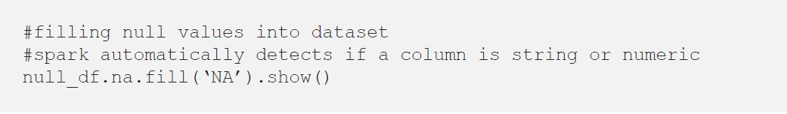

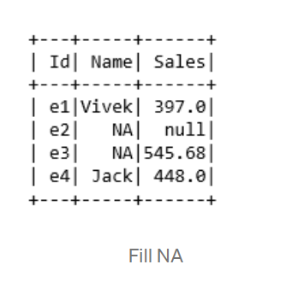

Figure 37 Filling with NA value

The second method is to fill missing value with ‘0’.

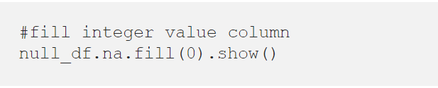

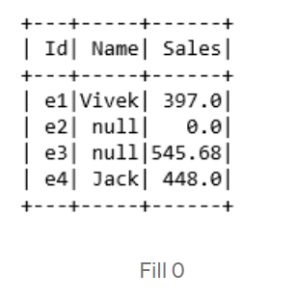

Filling Nulls on basis of column

The third way is to fill missing value with characters ‘Name Missing’.

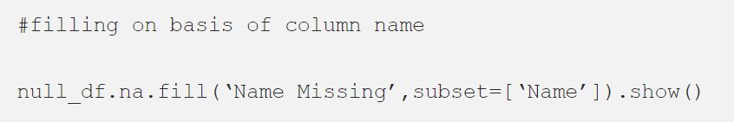

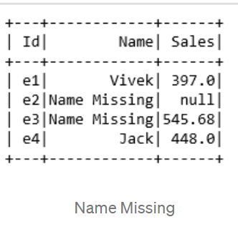

Figure 38 Filling Null with Character

Another way is to adding both information to multiple columns:

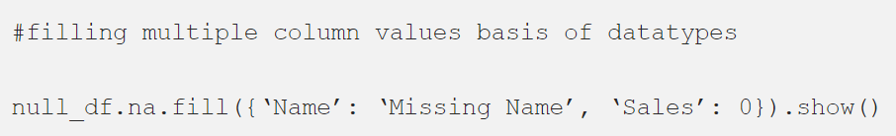

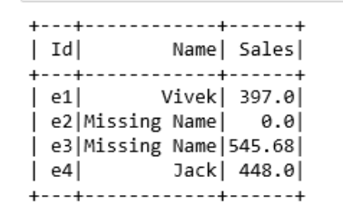

Figure 39 Fill Missing Value with multiple columns

**Finding Extremes and Outliers**



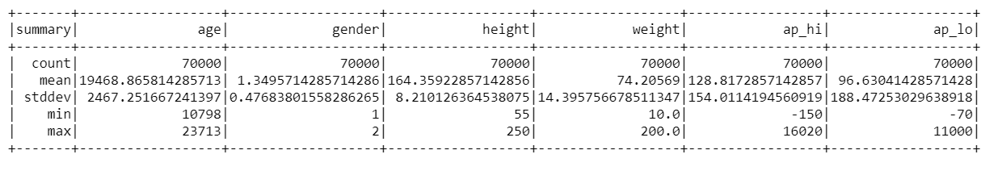



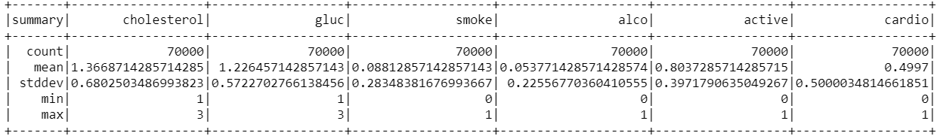

Figure 40 Description of Data

By insight deeply, the finding is from minimum height is 55 cm and minimum weight is 10 kg. That must be an error, since minimum age is 10798 days, which equals to 29 years. On the other hand, the maximum height is 250 cm and the highest weight is 200 kg, which might be irrelevant, when generalizing data. To deal with these errors, we can remove outliers. Then from the 68-95-99.7 rule, taking action to remove weights and heights, that fall below 2.5% or above 97.5% of a given range. The code is looking like below, which was done after the outliers were identical.

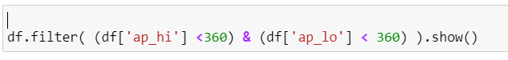

Simultaneously, in the dataset, some records have higher diastolic pressure compared to systolic which should be outliers or less logical in the dataset.

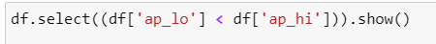

Figure 41 Outliers finding

Then the next step is to remove outliers, moreover blood pressure should be positive for the opposite negative value is not logical.

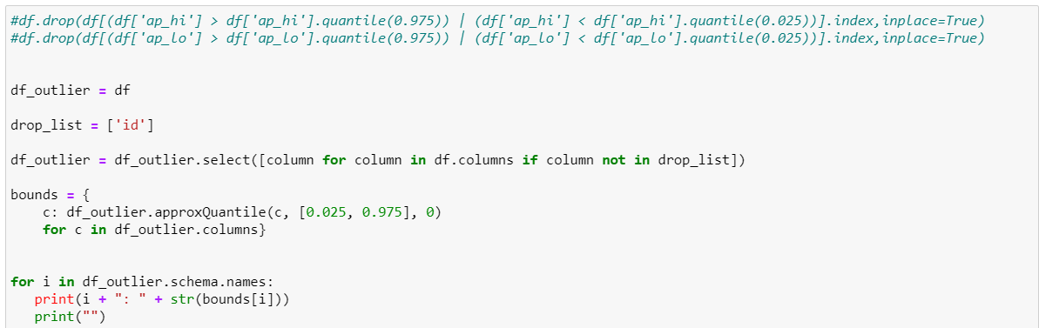

Figure 42 After removing outliers

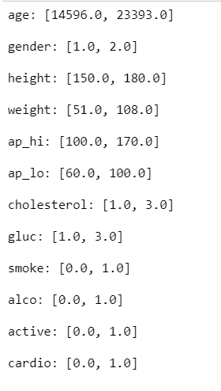

Figure 43 Results showing by calculation



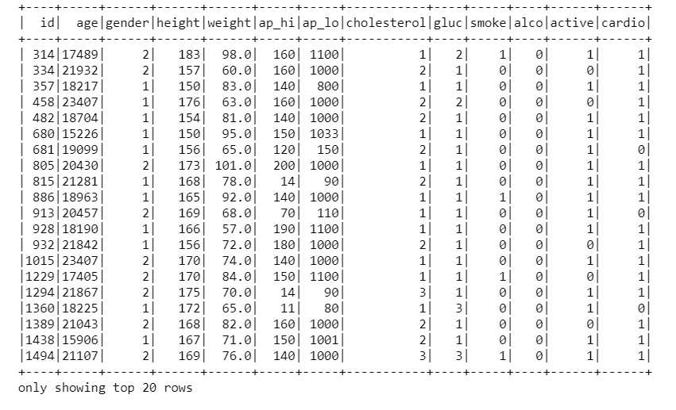

Figure 44 Preprocessing Result

Finding the original information about the `ap_hi` and `ap_lo` in the data set. From the chart below, there was no missing value in the `ap_hi` or `ap_lo`. The lower bound and upper bound are separately 100 and 170 for `ap_hi` and 60 and 100 for `ap_lo`.

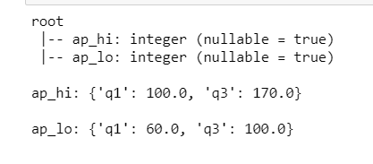

Finding the extreme distribution:

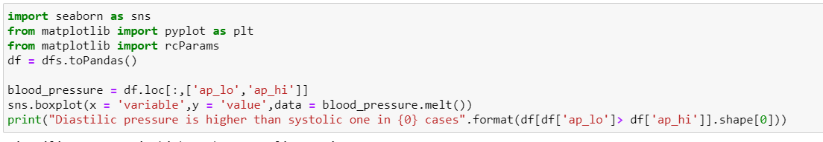

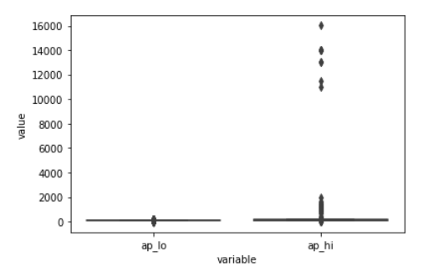

Figure 45 Boxing for outliers

* + 1. Multiple Variable Analysis and New feature created

Based on the target value analysis, it may be useful to visualize how the correlation variable in Matrix.

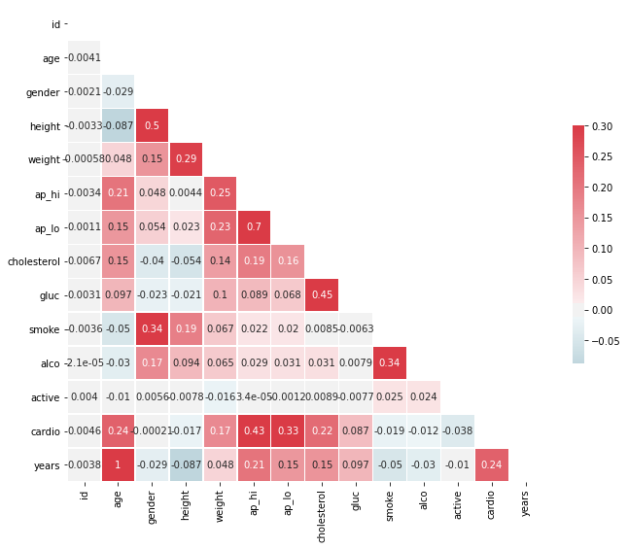

Figure 46 Correlations in co-variables for multiple analysis

From the figure, we can find the variable has high impact to target cardio but not too highly related. By creating a new feature/variable “violinplot” to show height distribution across gender.

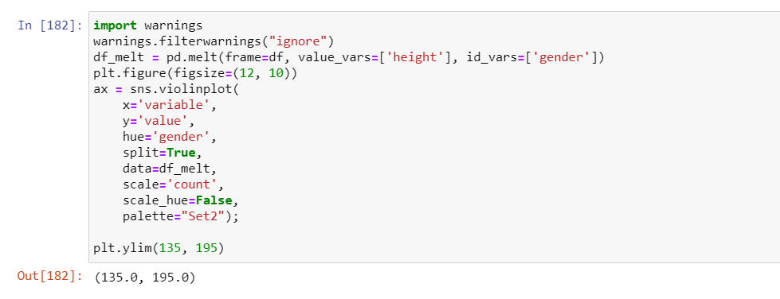

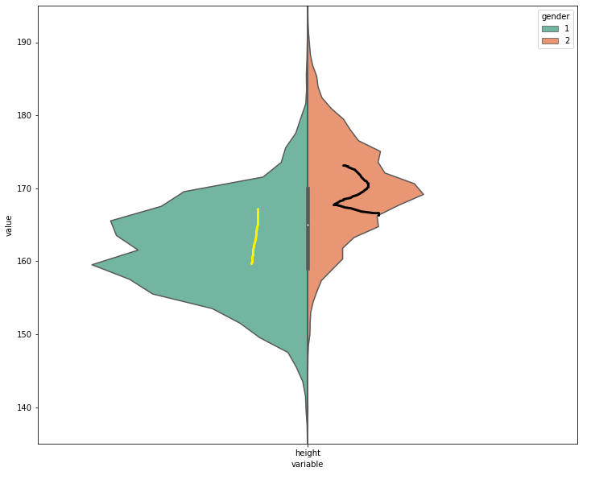

Figure 47 Height Distribution divided by Gender

From the figure above, it is easily to find the green one with ‘1’ is probably for female height mainly distributed from ‘155’ to ‘175’ ; the brown one with ‘2’ is lean to be mal height distributed from ‘160’ to ‘180’. Then we could create a new feature Body Mass Index (BMI):

$$BMI=\frac{{mass}_{kg}}{{height}_{m}^{2}},$$

BMI is an important and vital Index to evaluate health or ill situation by World Health Organization. Risks of coronary heart disease, ischemic stroke and type 2 diabetes mellitus increase steadily with increasing body mass index (BMI), a measure of weight relative to height. Raised body mass index also increases the risk of cancer of the breast, colon, prostate, endometrium, kidney and gall bladder. Mortality rates increase with increasing degrees of overweight, as measured by body mass index. To achieve optimum health, the median body mass index for an adult population should be in the range of 21 to 23 kg/m2, while the goal for individuals should be to maintain body mass index in the range 18.5 to 24.9 kg/m2. There is increased risk of co-morbidities for body mass index 25.0 to 29.9, and moderate to severe risk of co-morbidities for body mass index greater than 30.

(<https://www.who.int/gho/ncd/risk_factors/bmi_text/en/>). BMI will be introduced and processed in section 34. Data integration.

Adding a parameter BMI to the whole dataset.



By looking into the dataset, the dimension of raw dataset is as following, columns are 13 for 13 variables and 70000 for records.

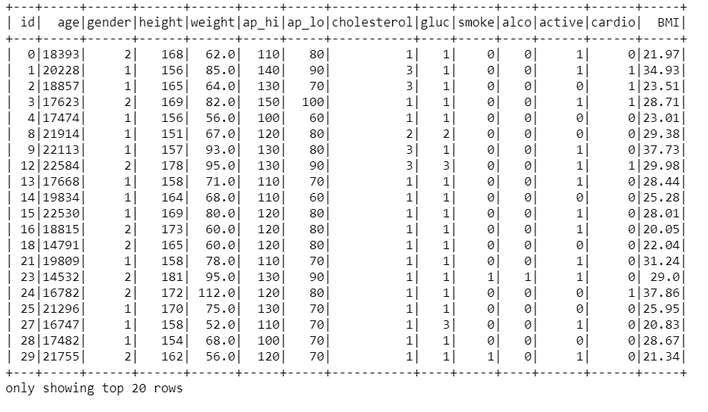

By removing outliers, the dimension of dataset is as followed, columns are still 13, but rows are reducing.

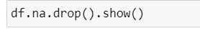

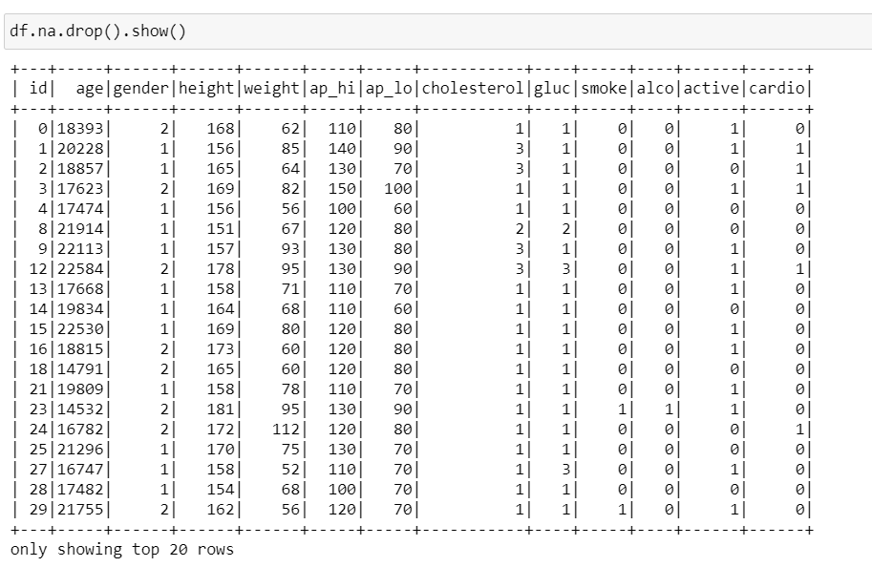

By adding one more feature, the dimension of dataset is as followed, columns are converted into 14 representing 14 variables with same number of rows.

Before processing duplicates,

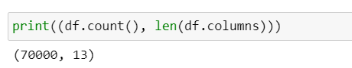

After processing duplicates showing below:

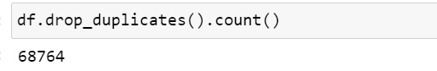

Add two variables, `years` and `bmi`





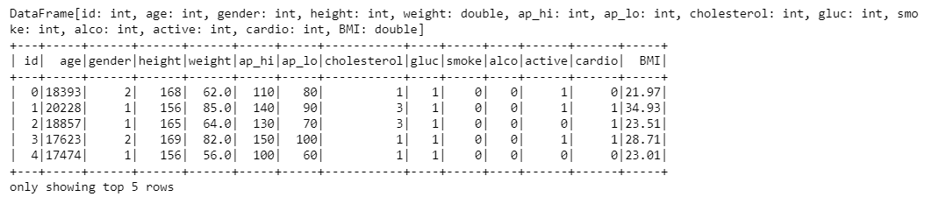

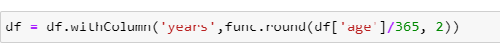

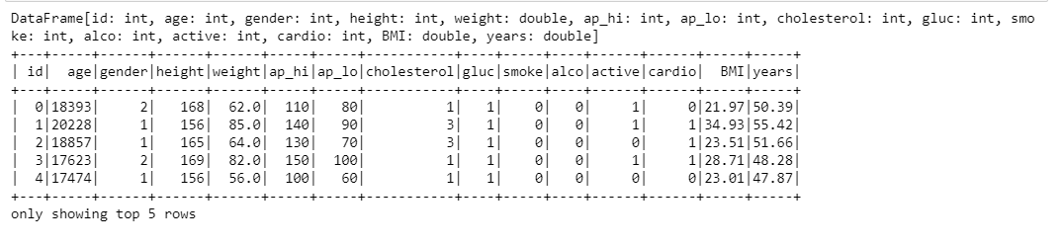

Apart from the features added above, four features of cholesterol_normal, cholesterol_well above normal, gluc_normal, gluc_well_above_normal were added which will be discussed in chapter 4 and chapter 8. Meantime, the two features “cholesterol” and “gluc'” were dropped.

* 1. Data Integration

From the section 3.3, it is a proposed direction to find the relation between new feature BMI and other variables and target variable. In this session, further discussion will be introduced in mining new feature discussed in section 3.3. Based on gender, the target is to find the relation between alco impact on genders and the working method to process the relation between BMI, alco, gender and the target variable.

Based on the information provided by WHO, normally people’s BMI is located from 18.5 to 25 which are boxing display of white and yellow boxes for both left cardio = ‘0’ healthy people and right cardio = ‘1’ with cardio record people.

Simultaneously, the yellow box represents alco using people; ‘1’ represents ‘female’ variable in ‘red’ circle; compared to ‘2’ ‘male’ variable in ‘blue’ circle.



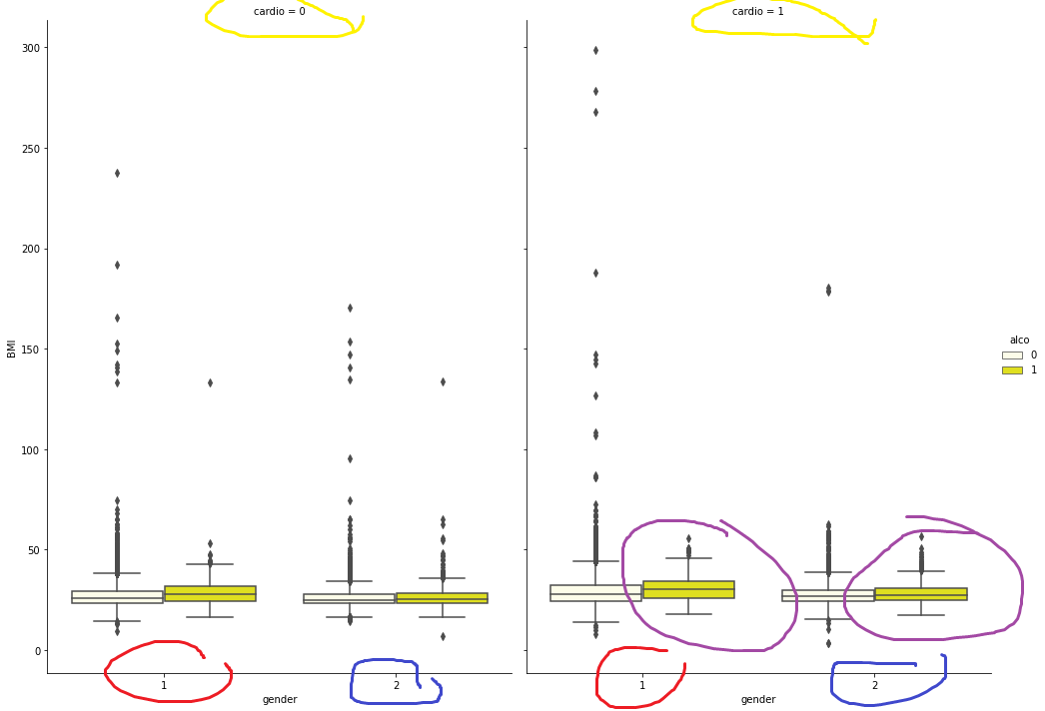

Figure 48 multiple variables evaluating relationship with target

From the figure above, it could be finding alco has much more impact to female than to male. Alco make female more likely to be cardio as well as much higher tendency to have BMI issue which will be discussed in Chapter 4 Data Transformation part and Chapter 8 Iteration part. When data needs transforming using one hot encoder.

* 1. Data Formatting

Based on all the processed in previous steps, the data is much tidy and clean with regular format. By further steps on, more actions also could be taken to active much formatted data. Take blood pressure to converge with illustration about body blood pressure If one’s systolic pressure (ap_hi) exceeds 180 or diastolic pressure (ap_lo) crosses 120, it is a stage that requires immediate medical attention. More detailed are uncovered from American Heart Association.

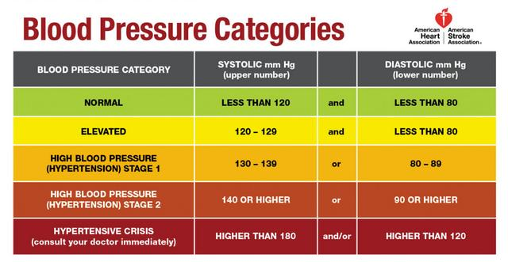

Figure 49 American Heart Association

By shape the dataset, the result shows differences for the dataset after re-formatting.

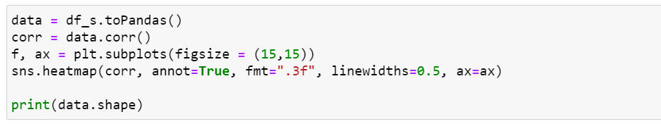

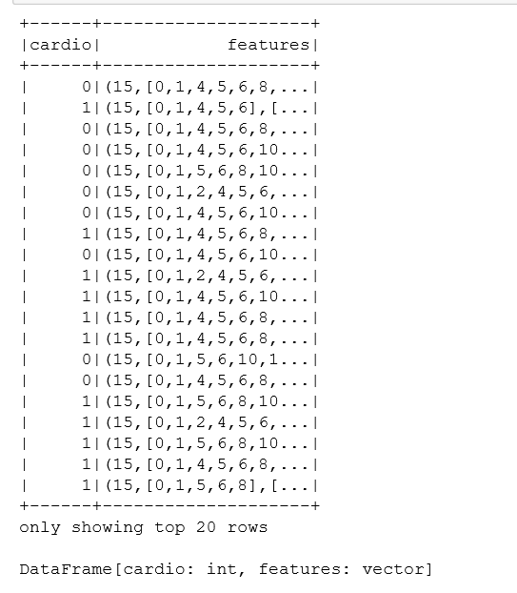

(68764, 11)

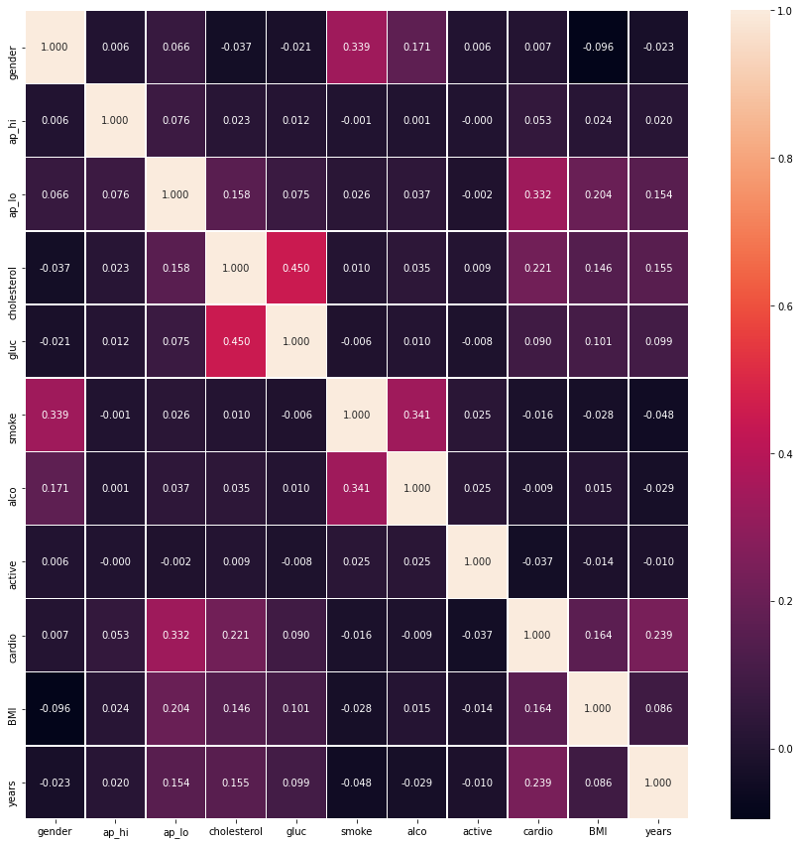

Figure 50 New dataset format for Data

1. **Data Transformation**
   1. Reduce the data

In previous Section 3, we got the convergent data from raw data. As mentioned in [Fayyad, 1996 #7], “Fourth is data reduction and projection: finding useful features to represent the data depending on the goal of the task. With dimensionality reduction or transformation methods, the effective number of variables under consideration can be reduced, or invariant representations for the data can be found”. In this section, we will take feature selection method to build a corresponding model to achieve the finding of important features search. The value transformed is processed in two part reduce features and exploratory Data Analysis and Data Preprocessing.

* + 1. Reduce Feature “id”

In this data set, from previous analysis, “id” is not associated with the cardio result. In this section, the following operations will be performed. 1. According to the analysis in the previous chapters, the user id has nothing to do with whether you have cardio. Therefore, the id feature will be removed. 2. Check if there are duplicate values, if so, discard duplicate values. 3. Transform age from unit days to unit years divided by 365.25. 4. Drop Duplicate

All the actions were performed in Python.

**Reducing ‘id’ variable showed below:**



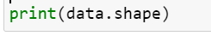

Finding the result is

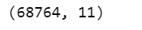

Showing numbers of duplicate values

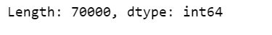

Dropping duplicate records

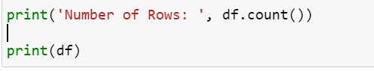

Showing result



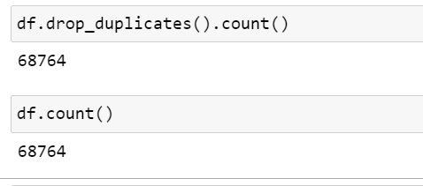

* + 1. Reduce Feature “height” and “weight”

By adding “bmi” feature into the dataset, the features constructed “bmi” could be reduced.

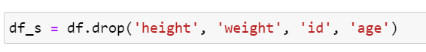

Audit the distribution of presence of cardio disease,

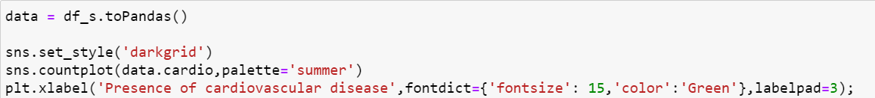

Checking if the targets are equally balanced:

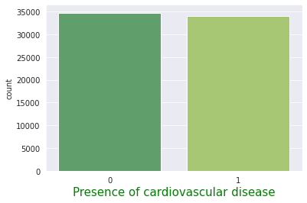

Figure 51 Visualizing Target Variables

The target data is equally balanced. Further visualization and more discussion about the data will be discussed in chapter 8.

* 1. Project the data
     1. Re-formatting the data

The original data for gender variable is marked as numerical “1” and “2” which likely for get high radio to be classified into positive for target variable. Based on previous analysis, the average height of male is higher compared to female. Thus, we reassigned gender from numerical to binary in code.

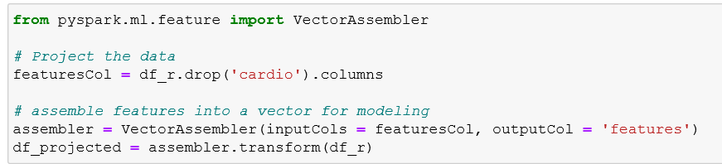

Transformed result shows

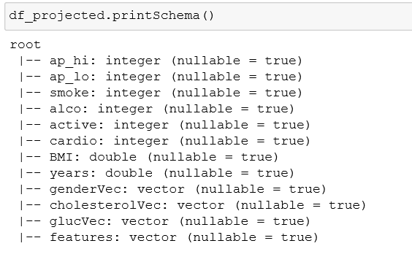

With distribution and relation to target variable.

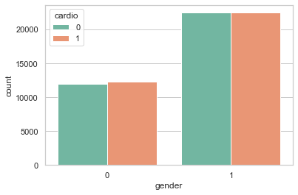

Figure 52 Gender Distribution with Target

Further distribution of other variables will be discussed later in chapter 8.

**Variable Transformation**

By looking into variables in the dataset caused cardio disease, the variables could be divided into two types: Non-modified Cause and Modifiable Cause. A further step goes to look insight of the variables and transformation if needed. Converting the age from number of days to categorical values.



*# According to US National Library of Medicine National Institutes of Health the age groups are classified*

According to the America National Library of Medicine National Institutes of Health, the age groups are classified as (0, 2], (2, 5], (5, 12], (12, 19], (19, 24], (24, 44], (44, 65], 65+ , the related information about `age` and target `cardio` could be a element, which will be discussed in further chapters. Advanced data mining and visualization will be discussed in the following chapters.

* + 1. One-Hot Encode Data Based on the Models

Returning from Chapter 7, when building models, the screen returns error. Then getting back for data format with illustration of definition and illustration of why the process to transform data type from “categorical” to “numerical” / “binary” is essential.

**Problems with Categorical Data**

There are some algorithms that can directly process categorical data. For example, decision tree can directly process categorical data without additional data transform. Some machine learning algorithms cannot directly process categorical data but need to use numerical input and output. In some cases, it really needs to be output as categorical data, and finally needs to be converted back to categorical data.

For categorical variables where no such ordinal relationship exists, the integer encoding is not enough. In fact, using this encoding and allowing the model to assume a natural ordering between categories may result in poor performance or unexpected results (predictions halfway between categories). In this case, a one-hot encoding can be applied to the integer representation. This is where the integer encoded variable is removed and a new binary variable is added for each unique integer value.

In following part, the binary variables were called as dummy variables. In the figure below, categorical data was transformed into dummy variable representing ‘cholesterol’ and ‘gluc’. As mentioned in chapter 3, when adding and dropping features, four features of cholesterol_normal, cholesterol_well above normal, gluc_normal, gluc_well_above_normal were added which will be discussed in chapter 4 and chapter 8. Meantime, the two features “cholesterol” and “gluc'” were dropped.

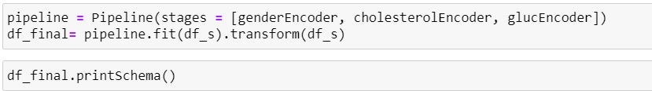

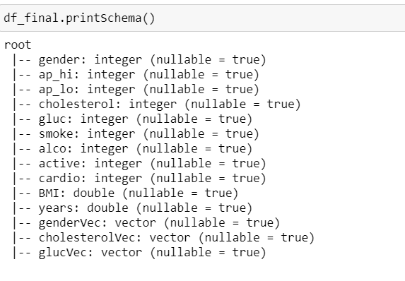

Then categorical data was transformed in data frame shows below:

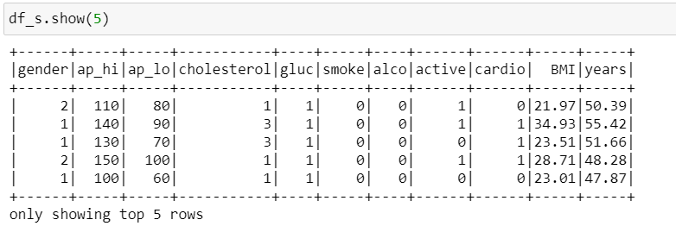

Figure 53 Final Data Format

After finishing the encoder process, the cleaned data could be transformed and projected into new data set considered as `df_final`.

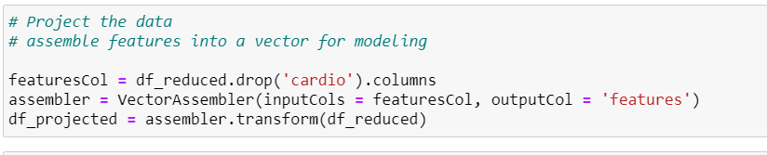

The final projected data and features could be illustrated as

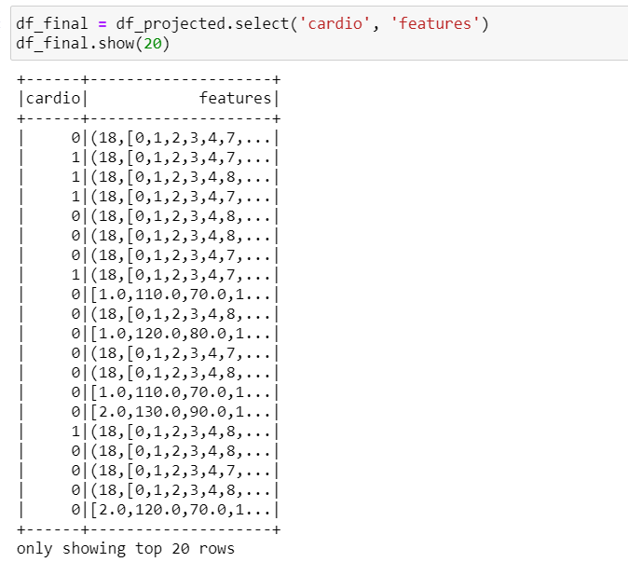

1. **Data Mining Method Select**
   1. Match the goals to methods of data mining

Data mining refers to the discovery and extraction of patterns and knowledge from large data sets of structured and unstructured data. Data mining technology has existed for decades, but recent advances in ML (machine learning), computer performance, and numerical computing have made data mining methods easier to implement on large data sets and business-centric tasks. The increasing popularity of data mining in business analysis and marketing is also attributed to the proliferation of big data and cloud computing. Large distributed databases and parallel data processing methods (such as MapReduce) make large amounts of data easy to manage, which is very useful for companies and academia. Similarly, cloud service providers (CSP) reduce the cost of storing and managing data. Cloud service providers provide a pay-as-you-go model for access to virtual servers, storage capacity (optical disk drives), GPU (graphics processing unit) and distributed databases. Therefore, companies can store, process, and analyze more data to gain better business insights.

On its own, the latest data mining methods are powerful in many tasks. Some of them are anomaly detection, grouping, classification, association rule learning, regression, and summarization. In any environment that people can think of, every task plays a vital role. For example, anomaly detection technology can help companies prevent network intrusions and data leakage. In turn, regression models can powerfully predict business trends, revenues, and expenses. Clustering techniques are most useful for grouping large amounts of data into cohesive entities, which can report internal and inter-dependent patterns and dependencies without knowing the rules of observation. As these examples show, data mining has the ability to provide data to entire companies and communities.

The data mining goal is to find the key features which will increase high risk of CVD. Based on the Objective, several data-mining methods could be used from the modeling vision. There are many ways to sort and analyze data. Which method to choose depends largely on our purpose (e.g., prediction, relationship inference) and data format (structured or unstructured). We can get a specific data setting that may be useful for one task but not so good for another. Therefore, in order for the data to be available, you need to understand the theoretical models and methods used to obtain the data and implement possible trade-offs and gaps in each model.

One way to view a mining model is to determine if it has parameters. When it comes to parameters, we can choose between parameter and non-parameter models. In the first type of model, we choose the function that we think best fits the training data. For example, we can choose a linear function of the form F (X) = q0 + q1 x1 + q2 x2 +. . . + qp xp, where x are the characteristics of the input data (eg, house size, floor, number of rooms) and q are the unknown parameters of the model. These parameters can be viewed as weights that determine the contribution of various characteristics (eg house size, floor, number of rooms) to the Y value of the function (eg house price). The task of the parametric model is then to find the Q parameters using some statistical methods, such as linear regression or logistic regression.

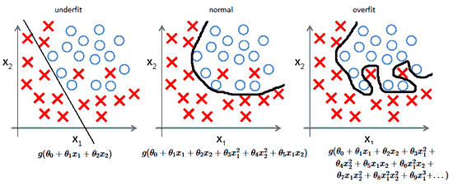

Figure 54 Underfitting, Normal, Overfitting

* 1. Select the appropriate data-mining methods

**Restrictive vs. Flexible Methods**

ML and data mining models can also differ in terms of flexibility. Parametric models such as linear regression is typically considered very restrictive because they require structured data and real responses (Y). However, this characteristic makes them suitable for inferring the relationship between traits (e.g., how the level of crime in the neighborhood affects house prices). Therefore, the restrictive models are interpretable and clear. However, this observation does not apply to flexible models (for example, without parameters). Since flexible models do not accept assumptions about the form of the function controlling the observation, they are less interpretable. However, in many circumstances the lack of interpretation is not a cause for concern. For example, when our only interest is the forecast of the stock price, we do not have to worry at all about the interpretability of the model.

**Supervised vs. Unsupervised Learning**

Today, we heard a lot about supervised and unsupervised machine learning. New neural networks based on these concepts are developing image and voice recognition or autonomous driving every day. However, a natural question is, what is the difference between a supervised learning method and an unsupervised learning method? The main difference lies in the form of the data used and its analysis method. In a supervised learning environment, we use labeled data containing the following:

Function / variable and dependent variable (yes or answer). This data is then entered into a learning algorithm that looks for models and functions that control the relationship between independent and dependent variables. The result function can then be used to predict future observations. In addition to monitoring during training, we also observe feature vectors (e.g., house size, floor). However, the difference in supervised learning has nothing to do with us (Y). In this case, we cannot apply a linear regression model because there is no predicted response value. That is why we work blindly without supervision.

**Data Mining Methods**

**Classification with Logistic Regression**

Classification is the process of determining which class/category an object belongs to. Classification techniques implemented by machine learning algorithms have been widely used in many applications ranging from spam filtering to medical diagnosis and recommendation systems. Similar to linear regression, in classification problems, we use a labeled training set that contains certain features. However, the observations in the data set are not mapped to quantitative values ​​such as linear regression, but are mapped to categorical values ​​(for example, categories). For example, the patient's medical history can identify two types of patients: benign and malignant cancer patients. Then, the task of the classification algorithm is to learn a function that can best predict which type of cancer (malignant or benign) the patient has. If there are only two classes, the problem is called binary classification. On the contrary, when we have more categories of data, we can use multi-category classification.

Logistic regression is one of the most common classification techniques in data science and ML. Logistic regression is based on the sigmoid function, which has an interesting feature: it maps any real number to the interval (0,1). As a result, it can be effectively used to evaluate the probability (between 0 and 1) that an observation falls into a specific category. For example, if we define a benign cancer as 0 and a malignant tumor as 1, then a logistic value of .6 means that the patient has a 60% chance of developing a malignant tumor. These attributes make the Sigmoid function useful for binary classification, but it can also be used for multiple classifications.

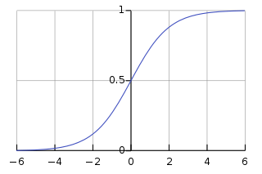

Figure 55 Logistic regression

**Clustering Methods**

Clustering is an unattended method and is useful in the absence of tagged data or no response value (y). Cluster observations in a data set involve dividing them into different groups so that the observations in each group are very similar to each other, while the observations in the different groups are less common. To illustrate this approach, let's take marketing as an example. Let's say we have a lot of data on consumers. These data may include average household income, occupation, distance to the nearest urban area, etc. This information can then be used to segment the market. Our task is to identify different customer groups without first knowing the common features that may exist with each other. You can then use this segmentation to tailor your marketing campaigns to specific consumer groups.

There are many different clustering techniques that can do this, but the most popular are the k-mean clustering algorithm and hierarchical clustering. In this section, we will describe the k-mean method, which is a very efficient algorithm that covers a wide range of applications. In K-means clusters, we want to divide the observations into a predetermined number of clusters. Although setting up multiple sets before creating sets is considered a limitation of the k-mean algorithm, it is still a very powerful technique. In our clustering problem, we offer training kits for consumers xi, ..., x (m), where each consumer has the feature xj. Functions describe various consumer attributes (such as average income, age, gender, etc.). The rule is that each observation (consumer) should belong to one class and no observation should belong to more than one class.

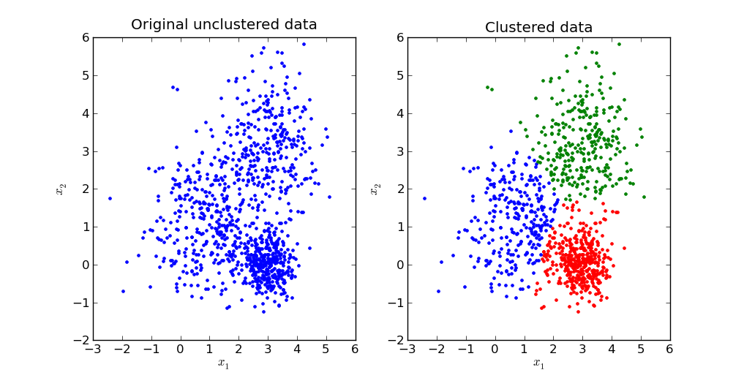

Figure 56 Clustering Methods

1. **Data Mining Algorithm Select**
   1. Exploratory of algorithms

Some algorithms are widely used universally in machine learning and data mining filed. Different algorithms have different pros and cons, especially when it has been put into different fields or been dealing with different data sets. In the following, popular data mining algorithms were discussed in detail.

**Top Data Mining Algorithms**

Data Mining Techniques are applied through the algorithms behind it. These algorithms run on the data extraction software and are applied based on the business need.

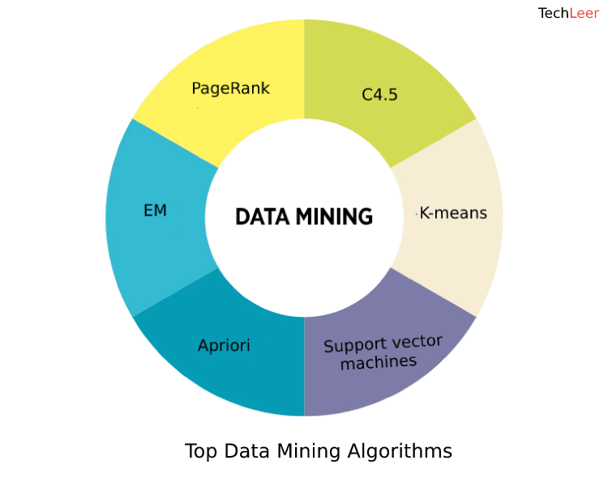

Figure 57 Top Data Mining Algorithms

Some algorithms are widely used in many organizations and research fields which are listed below:

K-means: It is a popular cluster analysis technique where a group of similar items is clustered together.

Apriori Algorithm: It is a frequent itemset mining technique and association rules are applied to it on transactional databases. It will detect frequent item sets and highlight general trends.

K Nearest Neighbor: This method is used for classification and regression analysis. The k nearest neighbor is lazy learning where it stores the training data and when a new unlabeled data comes, it will classify the input data.

Naves Bayes: It is a group of simple probabilistic classification algorithms which assume that each data object features are independent of the other. It is an application of Bayes Theorem.

AdaBoost: It is a machine learning meta-algorithm, that is used to improve performance. Ada-boost is sensitive to noisy data and outliers.

1. C4.5:

C4.5 is an algorithm that is used to generate a classifier in the form of a decision tree and has been developed by Ross Quinlan. And to do the same, C4.5 is given a set of data that represent things that have already been classified. C4.5 that is often referred to as a statistical classifier is basically an extension of Quinlan's ID3 algorithm. The decision trees that are generated by C4.5 can be further used for classification. The C4.5 algorithm has also been described as "a landmark decision tree program that is probably the machine learning workhorse most widely used in practice to date" by the authors of the Weka machine learning software.

2. k-means:

k-means clustering that is also known as nearest centroid classifier or The Rocchio algorithm is a method of vector quantization, that is considerably popular for cluster analysis in data mining.

k-means is used to create k groups from a set of objects just so that the members of a group are more similar. It is a well-known popular cluster analysis technique used for exploring a dataset.

3. Support vector machines:

When it comes to machine learning, support vector machines that are also known as support vector networks are basically supervised learning models that come with associated learning algorithms which then analyze data that are used for the analysis of regression and classification.

An SVM model is created that is a representation of the examples as points in space, that are further mapped so that the examples of the separate categories are then divided by a clear gap that is ought to be as wide as possible.

4. Apriori:

Apriori is an algorithm that is used for frequent itemset mining and association rule learning overall transactional databases. The algorithm is proceeded by the identification of the individual items that are frequent in the database and then extending them to larger itemset as long as sufficiently those item sets appear often enough in the database. These frequent itemset that are determined by Apriori can be used for the determination of association rules which then highlight general trends.

5. EM (Expectation-Maximization):

An expectation–maximization (EM) algorithm, when it comes to statistics is an iterative method that is used to find maximum a posteriori(MAP) or maximum likelihood estimates of parameters in statistical models, that basically depends on unobserved latent variables.

6. PageRank (PR):

PageRank (PR) that was named after Larry Page who is one of the founders of Google is an algorithm that is used by Google Search to rank the websites in their search engine results. PageRank, that is the first algorithm that was used by the company is not the only algorithm that is being used by Google to order search engine results, but it is the best-known way of measuring the importance of website pages.

7. AdaBoost:

Adaptive Boosting or AdaBoost, that has been formulated by Yoav Freund and Robert Schapire is a machine learning meta-algorithm, that won the founders the 2003 Golden Prize for the same. The algorithm can be used in composition with many other types of learning algorithms in order to improve performance. AdaBoost is sensitive to noisy data as well as outliers.

8. kNN:

The k-nearest neighbors’ algorithm (k-NN) is a type of lazy learning or instance-based learning and is considered as a non-parametric method that is used for classification and regression. In both the mentioned cases, the input consists of the k closest training examples in the feature space and the output depends on whether the algorithm is being used for classification or regression. This kNN Algorithm is considered and is also among the simplest of all machine learning algorithms.

9. Naive Bayes:

When it comes to machine learning, Naive Bayes classifiers that are considered to be highly scalable are known to be a family of simple probabilistic classifiers that are based on the application of Bayes' theorem with the help of strong independent assumptions between the features.

10. CART:

CART is an algorithm that basically stands for classification and regression trees. It is a decision tree learning technique that either outputs classification or regression trees and similarly like C4.5, CART is also a classifier.

Many of the reasons that a user would use C4.5 for also apply to that of CART, since both of them are decision tree learning techniques and features like ease of interpretation and explanation are also applied to CART as well.

* 1. Algorithm Selection

Data mining is known as an interdisciplinary subfield of computer science and basically is a computing process of discovering patterns in large data sets. It is considered as an essential process where intelligent methods are applied in order to extract data patterns.

Given below is a list of Top Data Mining Algorithms from both pros and cons to discuss all the algorithms should be used in what kind of situation or probably not to use in what kind of situations.

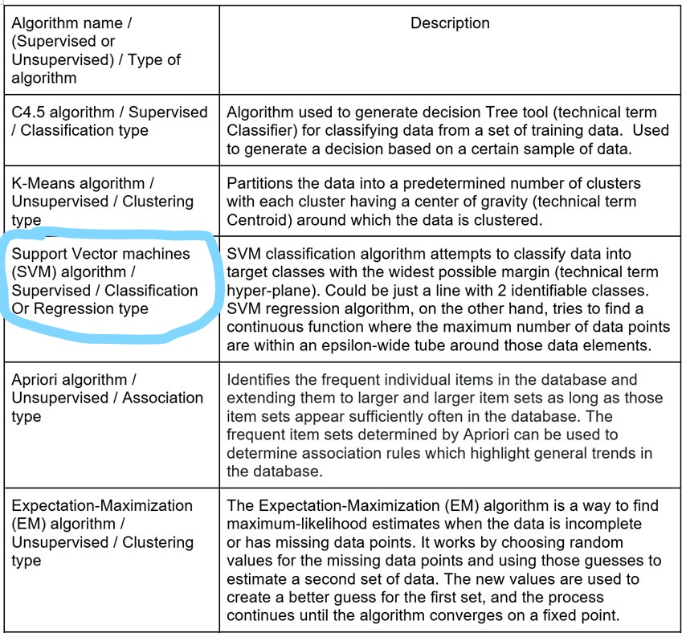

Figure 58 Algorithms Selection-1

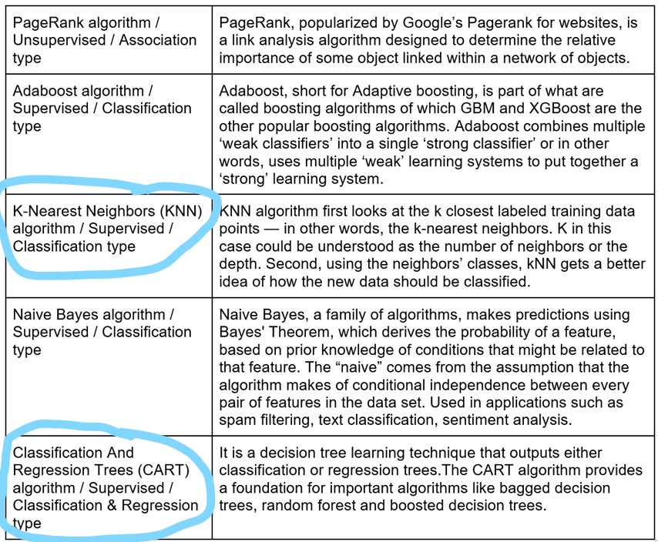

Figure 59 Algorithm Selection -2

Besides algorithm listed above, more popular methods have merged recently, like neuron network, a popular artificial intelligent machine learning method to process data mining data.

* 1. Build/Select Models with Algorithm/Model Parameter(s)
     1. Discovering relationship between model and features

It has been discussed in the previous chapters, and after the preprocessing in Chapter 3, and the transform in Chapter 4, new variables and new variable forms are obtained. In this section, before modeling and selecting parameters, first explore the direct relationship between each variable in the newly built database and the target variable. The next content that still needs to be discussed is model selection, parameter selection, and why such a choice is made.

Draw the relationship between the new variables and the target variable in below:

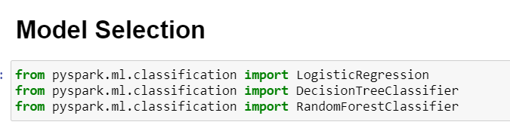

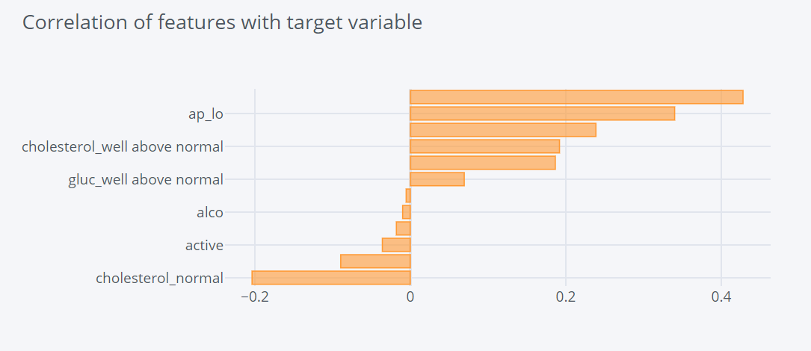

Figure 60 Relation between New Variables and Target Value

* + 1. Parameters to evaluate model

When the stage comes to build a model for a classification problem the first thing is to look at the accuracy of that model as the number of correct predictions from all predictions made. This is the classification accuracy. Once you have a model that you believe can make robust predictions you need to decide whether it is a good enough model to solve your problem. Classification accuracy alone is typically not enough information to make this decision. However, accuracy is the starting point. It is the number of correct predictions made divided by the total number of predictions made, multiplied by 100 to turn it into a percentage. Thus, “accuracy” will be considered as one evaluation parameter. For the dataset is constructed by binary variables, Precision and Recall performance measures is extremely essential to evaluate the model for a binary classification problem. “Precision” is the number of True Positives divided by the number of True Positives and False Positives. Put another way, it is the number of positive predictions divided by the total number of positive class values predicted. “Recall” is the number of True Positives divided by the number of True Positives and the number of False Negatives. Put another way it is the number of positive predictions divided by the number of positive class values in the test data. It is also called Sensitivity or the True Positive Rate. “F1 Score” is the 2*((precision*recall)/(precision + recall)). It is also called the F Score or the F Measure. Put another way, the F1 score conveys the balance between the precision and the recall. Therefore “F1 score” is selected as for the data mining model evaluation another evaluation parameter. F1 score is applicable for any particular point of the ROC curve. This point may represent for example a particular threshold value in a binary classifier and thus corresponds to a particular value of precision and recall. F score is a smart way to represent both recall and precision. For F score to be high, both precision and recall should be high. Thus, “the ROC curve” is also considered in the final analysis for various levels of thresholds and has many F score values for various points on its curve.

1. **Data Mining**
   1. Creating Logical Tests(s)

In this section, python scikit-learn model was used to split data. The first step is to separate target variable from the whole dataset as well as defining training set and testing set.

Adjusting all the variables to suit training and testing datasets. In this section, the main effort is to discussion why the whole dataset was split into 30/70, or 20/80 as testing/training set. More discussion will be illustrated in chapter 8. In this iteration, 30/70 was used to train and test model.

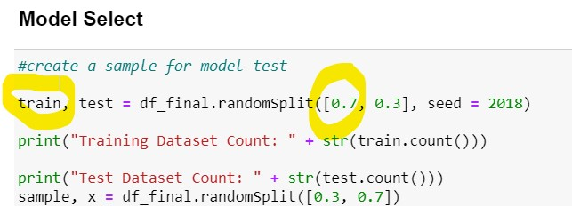

Training and Testing instances:

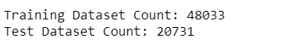

In machine learning, when we train the model, how do we verify the model? (In other words, how do I know if the trained model is good?) There are several verification methods:

**The first way:** use all the data set as the training set, then use the training set to train the model, and use the training set to verify the model (if there are multiple models to choose, then finally choose the model with the smallest training error as the best model ) This method is obviously not feasible, so the training set data has been used in the model fitting, and then using the same data to verify the model, the result must be too optimistic. If we evaluate and select multiple models, we can find that the more complex the model, the smaller the training error. When the training error of a model seems perfect, the model may have been severely over-fitted. Close. This has been mentioned in the article "Over fitting & Under fitting". (We call this model selected by the training error gm-hat).

**The second way:** divide the data set into training set and test set randomly, then use the training set to train the model, and use the test set to verify the model (if there are multiple models to choose, then finally choose the model with the smallest test error as Best model).

What kind of model is good? Obviously, the model with the smallest generalization error is the best, but we do not have such a test set that can measure the generalization error of the model. Therefore, we take part of the data as the test set and use its error to simulate the generalization error. Separating part of the data as the test set means that the training set is smaller than the original. It can be seen from the learning curve that a model trained with less data will have a larger test error. Therefore, for the evaluation and selection of multiple models, a reasonable approach is: After training each model with the training set, use the test set to select the best model (we call this model gm*-), and record the best Various settings of the model (for example, which algorithm to use, how many iterations, what is the learning rate, what is the method of feature conversion, what is the regularization method, what is the regularization coefficient, etc.), and then use the entire data After training a new model on the set, as the final model (we call this model gm*), the model effect will be better, and the test error will be closer to the generalization error.

The following figure shows the expected generalization error and ideal generalization error (black line) of each model-gm*- (red line), gm* (blue line), gm-hat (black solid line) as the test set increases Dotted line) change trend:

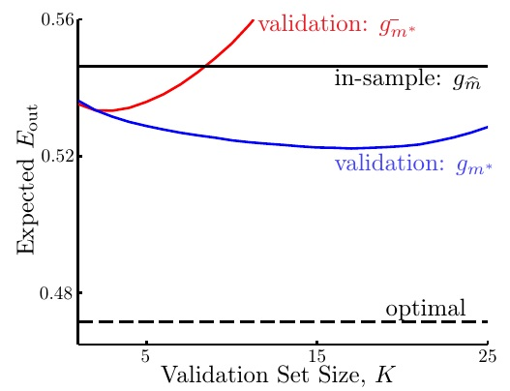

Figure 61 Validation set

It can be seen that gm* (blue line) performs best and is closest to the ideal generalization error (black dotted line). And as the test set gets larger and larger, the performance of gm*- (red line) is first closer to gm* (blue line), then it gets worse and worse than gm* (blue line), and finally worse than gm-hat (black line) solid line). This is because the larger the test set, the less data is used for training, and the effect of the trained model will definitely be bad. Therefore, when choosing the size of the test set, there is actually a dilemma: if you want to make the expected generalization error of gm* (blue line) close to the ideal generalization error, you need to make the test set larger, because there is There is enough data to simulate the unknown, but in this way, the gap between the expected generalization error of gm* (blue line) and gm*- (red line) is relatively large; and if you want to make gm* (blue line) and The expected generalization error of gm*- (red line) is close, so the test set needs to be smaller, because there is enough data to train the model, but at this time the expected generalization error of gm* (blue line) is the ideal generalization The gap between the errors is large. Generally speaking, people usually set the size of the test set to 20%~30% of all data.

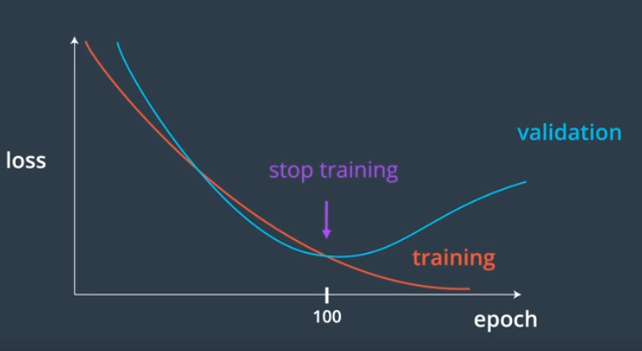

Figure 62 Training and Validation

Many materials divide the data into training set (70%-80%) and test set (20%-30%) in this way. The premise of this is to list the possible settings of the model separately, train different models, then use the test set to select the best model, and then use all the data to retrain according to the settings of the best model A final model. There are two problems with this. First, there are usually many hyperparameters of the model, and it is unlikely that we will list all possible settings. The hyperparameters usually need to be adjusted according to the actual situation. If the test results of the model are not satisfactory, then we need to go back and retrain the model. Although the test set is not used for model training, if we constantly adjust the model based on the test error, this will bring the test set information into the model. Obviously, this is not feasible, because the test set must be data that we have never seen before, otherwise the result will be too optimistic, and it will lead to overfitting. Second, what is the generalization error of the final model? We still cannot evaluate. Because we have retrained all the data to produce the final model, there is no data that has never been seen before to test the final model.

**The third method**: randomly divide the data set into training set, validation set and test set, then use the training set to train the model, use the validation set to verify the model, adjust the model according to the situation, select the best model, and then use training The final model is trained on the data set and the validation set, and finally the final model is evaluated with the test set.

This is actually the entire process of model evaluation and model selection. In the second method, we have divided the data set into a training set and a test set. Now we need to separate a test set for the final model evaluation. Because there is already a test set, we renamed one of the test sets used for model selection to the validation set to prevent confusion. (In some data, the data set is divided into training set and test set first, and then the training set is divided into training set and validation set).

The first few steps are similar to the second method: first use the training set to train the model, and then use the validation set to verify the model (note: this is an intermediate process, at this time the best model has not been selected), and constantly adjust according to the situation Model, select the best model (validation error is used to guide us which model to choose), record the settings of the best model, and then use (training set + validation set) data to train a new model based on this, As the final model, finally use the test set to evaluate the final model.

Since the information of the validation set data will be brought into the model, the validation error is usually smaller than the test error. At the same time, it should be remembered that the test error is the final result we get. Even if we are not satisfied with the test score, we should not go back to re-adjust the model, because this will bring the test set information into the model.

**The fourth method:** cross validation

**The fifth method:** Self-help method

To sum up:

Training Set: Used to train the model.

Validation Set: used to adjust and select models.

Test Set: Used to evaluate the final model.

Generally speaking, when dividing the data into three parts: training set (60%), validation set (20%), and test set (20%). Use the training set to train the model, and then use the validation set to verify the model, continuously adjust the model according to the situation, select the best model, record the choices of the best model, and then use it accordingly (training set + validation set) The data trains a new model as the final model, and finally uses the test set to evaluate the final model.

* 1. Conduction Data Mining (Running the model)

In this section, models selected from previous chapters were conducted and running in Python with evaluation parameters. Classifiers which have been selected are 1. Logistic Regression; 2. Decision Tree; 3. Random Forest.

* + 1. Logistical Regression

In this part, logistical regression is used to build training, predicting, and evaluating part. The training part gets the ROC score.

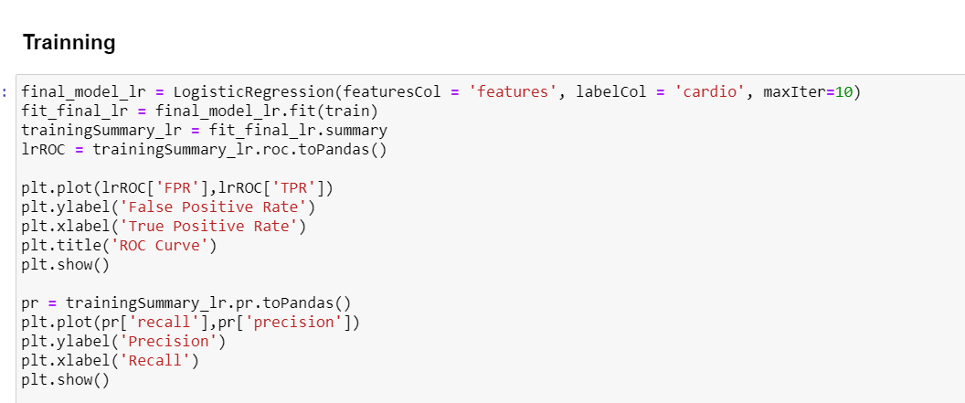

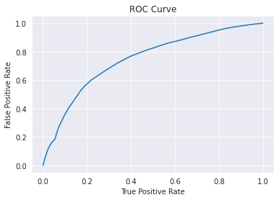

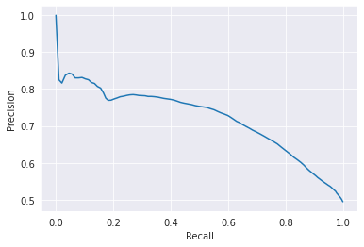

As defined in previous code, the next step is to count the starting time to run the code and the finish time to run the code followed by running the results based on the models/ classifiers above. Simultaneously, the evaluation parameters for the models are also performed in this section.

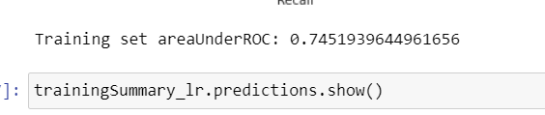

The models were trained by the training data,

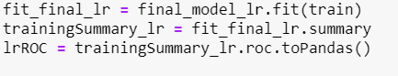

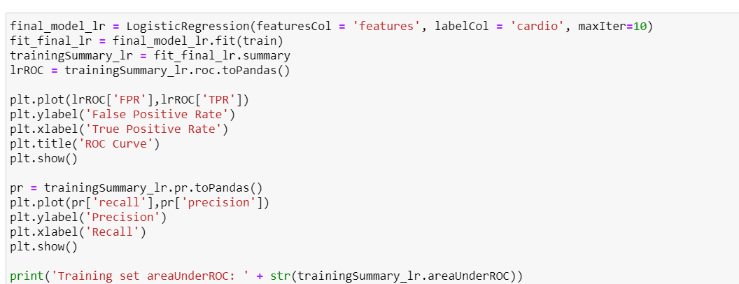

then by input testing data X_test, with using trained models followed by predicting data.

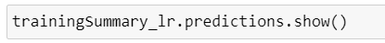

Finally, the results came out at “pred”, by compared with y_test. The error rate, the “accuracy” and “F1-Score” were stored in results.

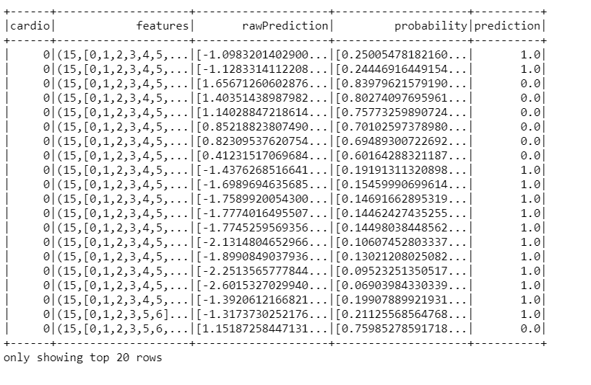

Then the result comes from the prediction part. By giving the information, the prediction could get from the training model.

* + 1. Decision Tree

Then the result comes from the prediction part. By giving the information, the prediction could get from the training model. The depth of `decision tree` could be used to train by different numbers of `3`, `5`, ``10` , and the accuracy of results are different based on the model training.

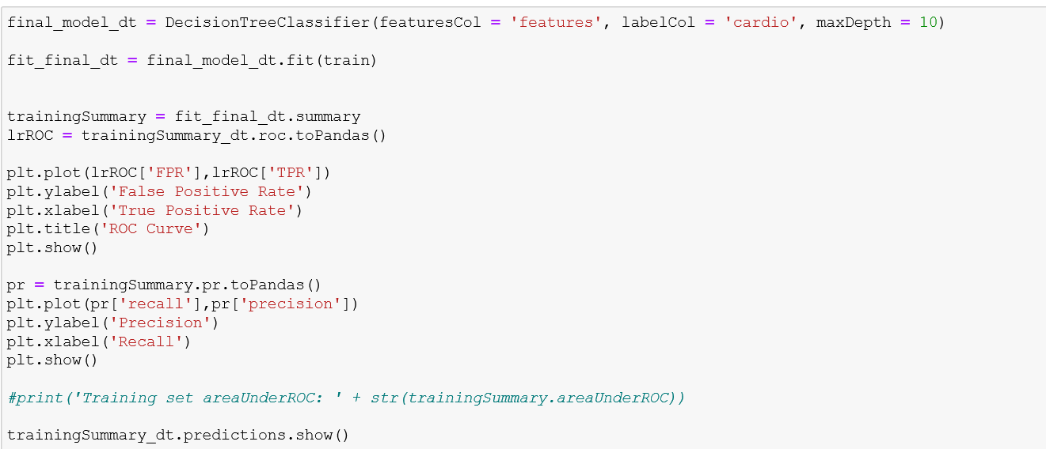

* + 1. Random Forest

Then the result comes from the prediction part. By giving the information, the prediction could get from the training model. The depth of `decision tree` could be used to train by different numbers, say 10, 50 and 100.

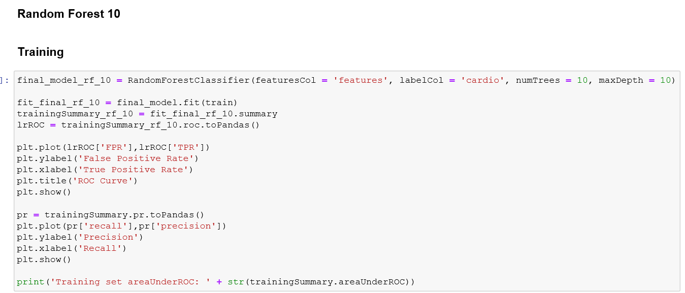

Figure 63 Random Forest 10

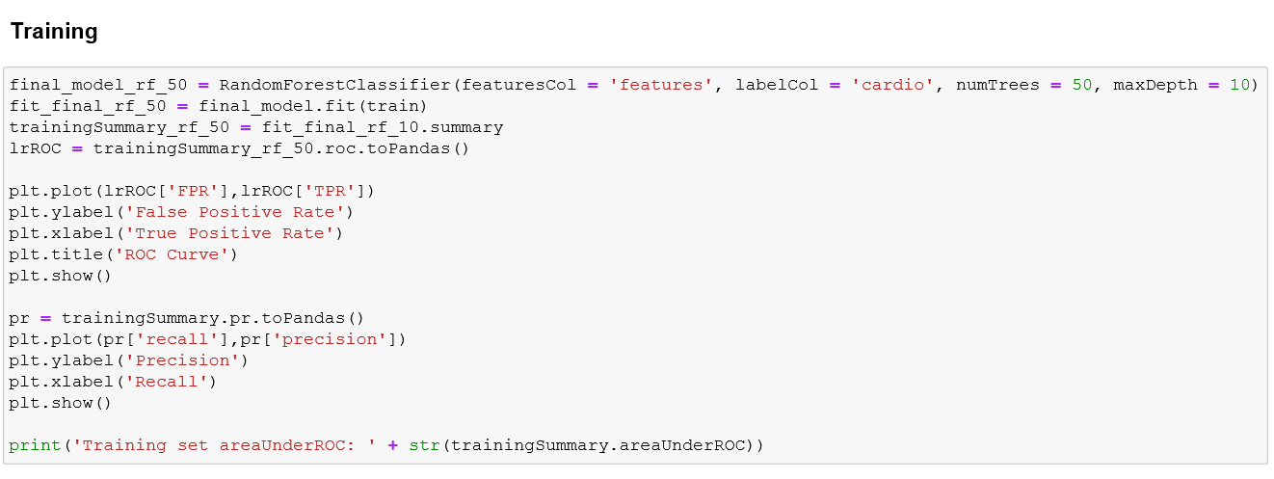

Figure 64 Random Forest 50

Setting for random forest 100.

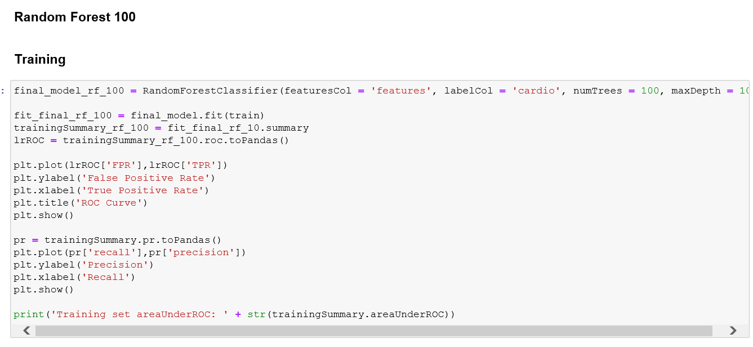

Figure 65 Random Forest 100

* 1. Patterns Searching

In this section, patterns used above have been discussed definition, general cases, and the results we are expected in patterns. More detailed study and discussion of the results will be discussed in Chapter 8.

* + 1. Logistical Regression

**Logistic Function**

From the result above, Logistical Regression has achieved highest accuracy and extremely high F1_score. The followings are discussed about logistic regression.

Logistic regression is named for the function used at the core of the method, the logistic function. The [logistic function](https://en.wikipedia.org/wiki/Logistic_function), also called the sigmoid function was developed by statisticians to describe properties of population growth in ecology, rising quickly and maxing out at the carrying capacity of the environment. It is an S-shaped curve that can take any real-valued number and map it into a value between 0 and 1, but never exactly at those limits. 1 / (1 + e^-value)

Where e is the [base of the natural logarithms](https://en.wikipedia.org/wiki/E_(mathematical_constant)) (Euler’s number or the EXP() function in your spreadsheet) and value is the actual numerical value that you want to transform. Below is a plot of the numbers between -5 and 5 transformed into the range 0 and 1 using the logistic function.

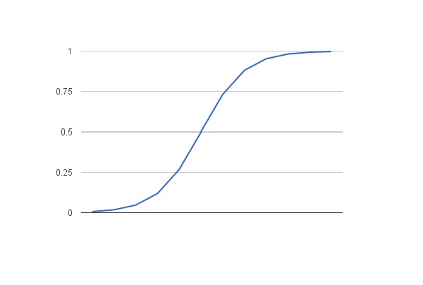

Logistic regression uses an equation as the representation, very much like linear regression. Input values (x) are combined linearly using weights or coefficient values (referred to as the Greek capital letter Beta) to predict an output value (y). A key difference from linear regression is that the output value being modeled is a binary value (0 or 1) rather than a numeric value.

In order to discover the pattern insight, more explorations were deployed in this session from Decision Tree and Random Forest perspectives.

Models for decision tress are modeled with six parameters as well as random forest.

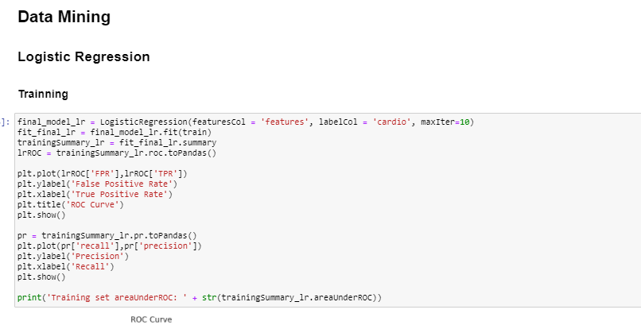

Developing factors of features from decision tree perspective with accuracy.



The above shows the ROC curve for true positive and false positive.

Also, when multi-layers were introduced into random forest, the accuracy is also proved

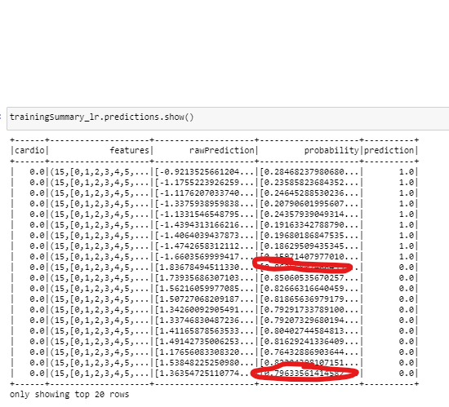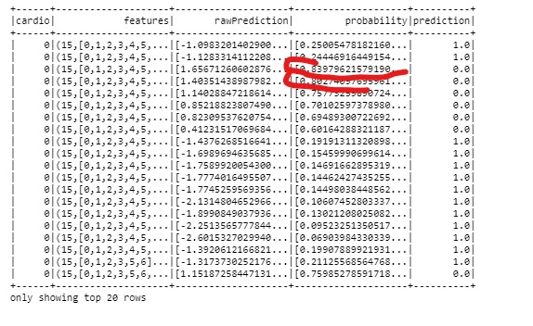

The results of multilayer random forest are 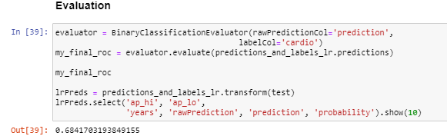.

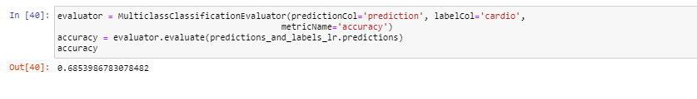

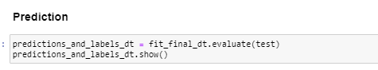

* + 1. Decision Tree

The decision tree also could use separated maxDepth by `10`, ``

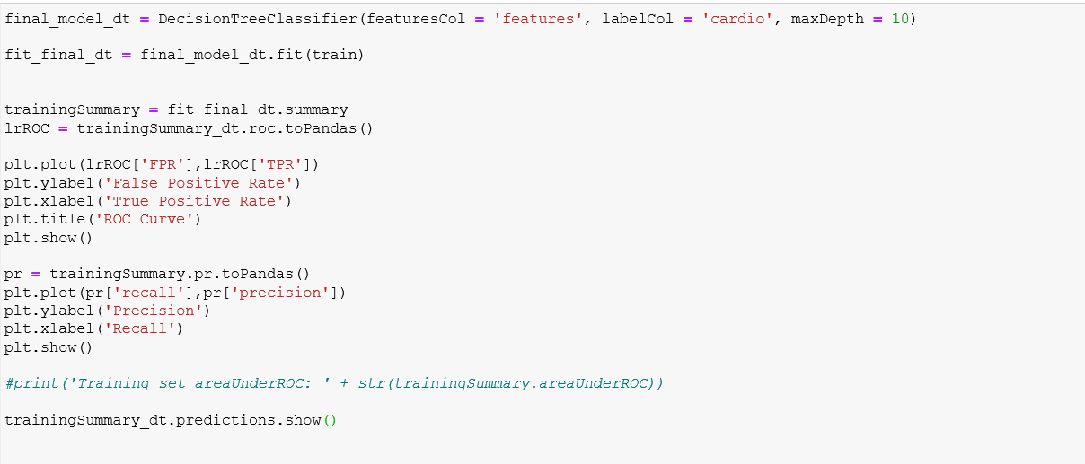

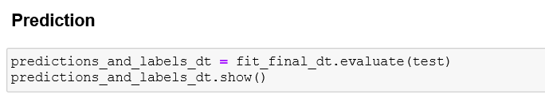

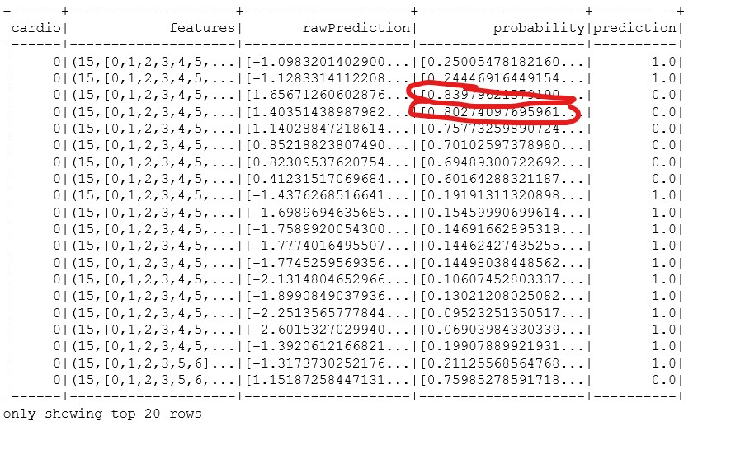

Depth were set to `3`.

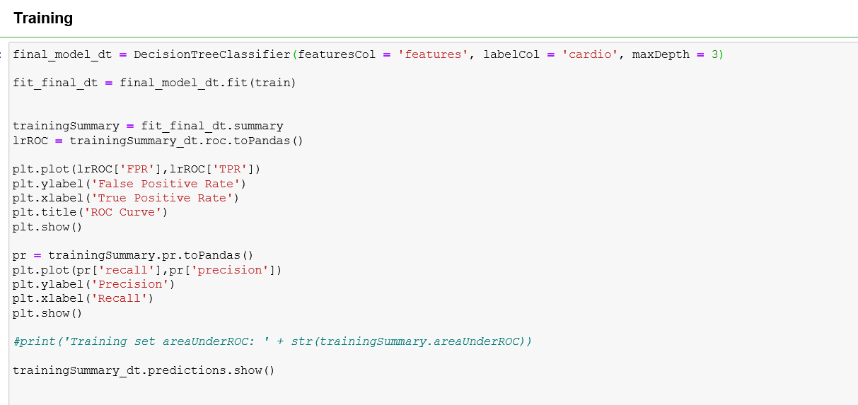

Figure 66 Depth 3

The prediction result is :

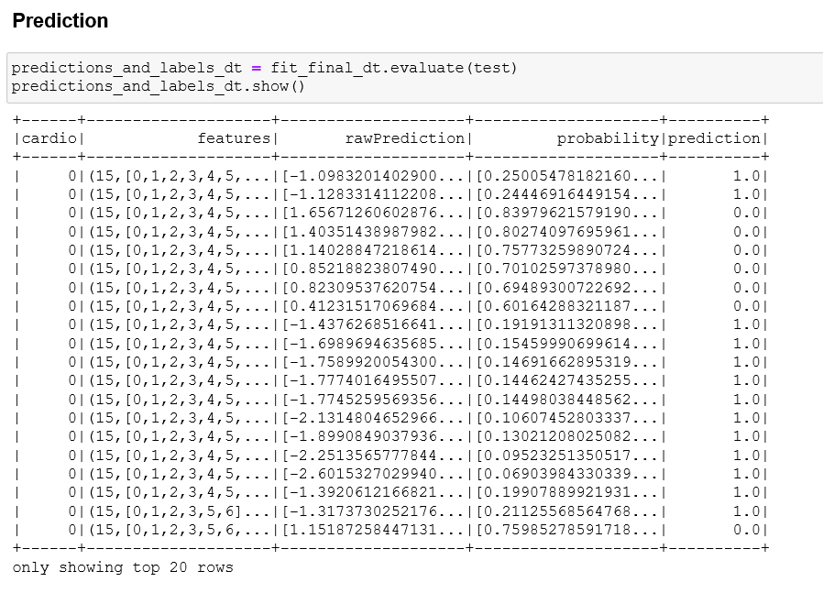

Figure 67 Prediction Result

Depth were set to `5`.

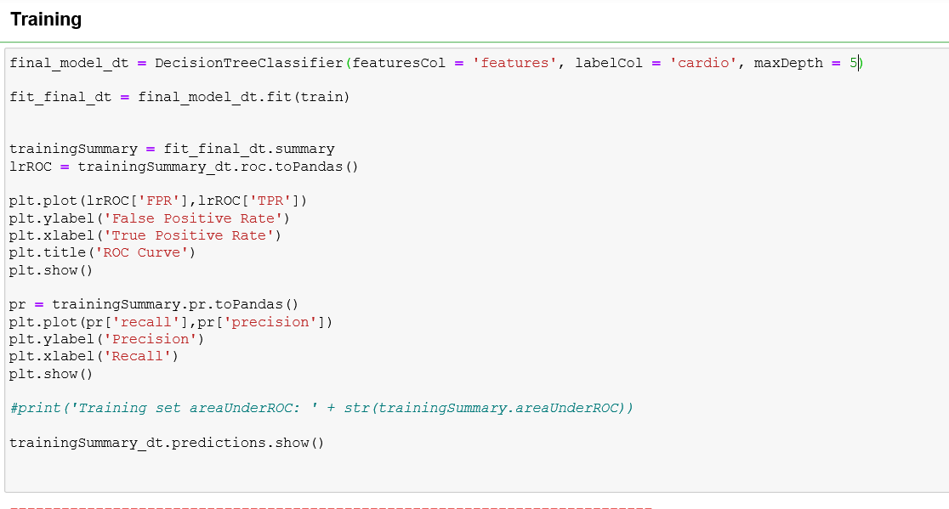

Figure 68 Setting Depth `5`

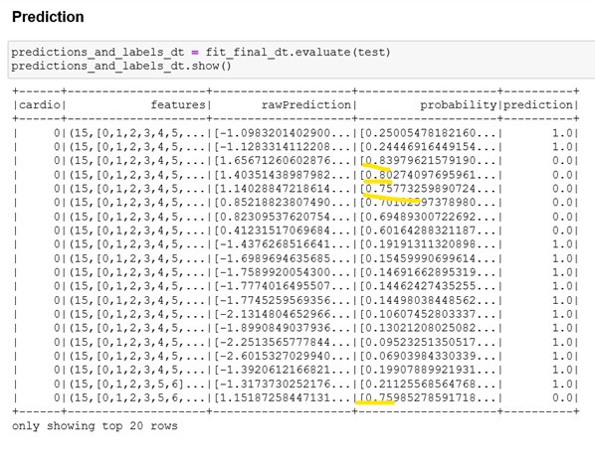

Figure 69 Prediction Result

* + 1. Random Forest

The random Forest maxDepth was selected and set as `10`, and trees `10`, `50`, and `100 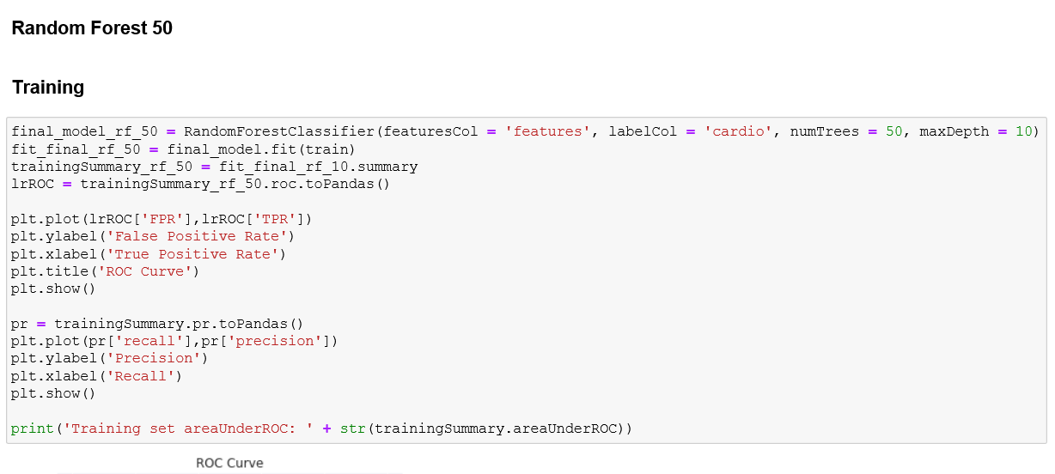` to find different result. The setting is ‘10’ shown below.

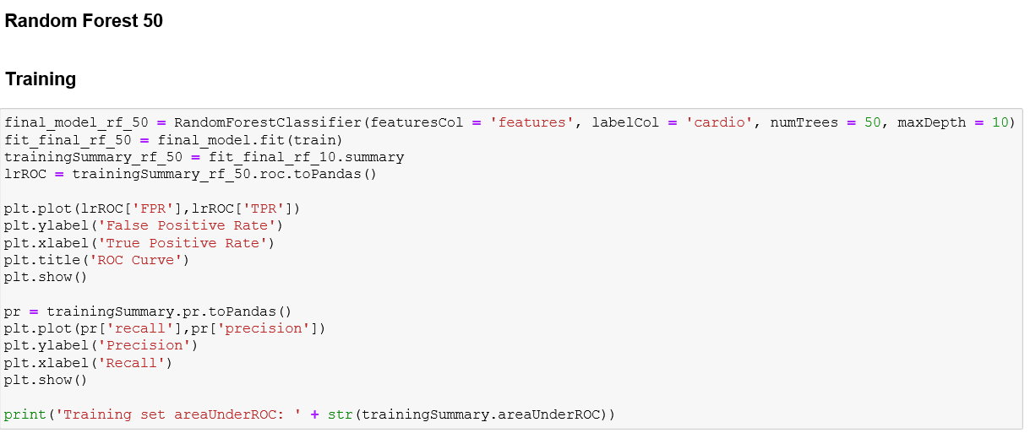

Figure 70 Random Forest 50 Setting

The random Forest maxDepth was selected and set as `10`, `50` and `100` to find different result.

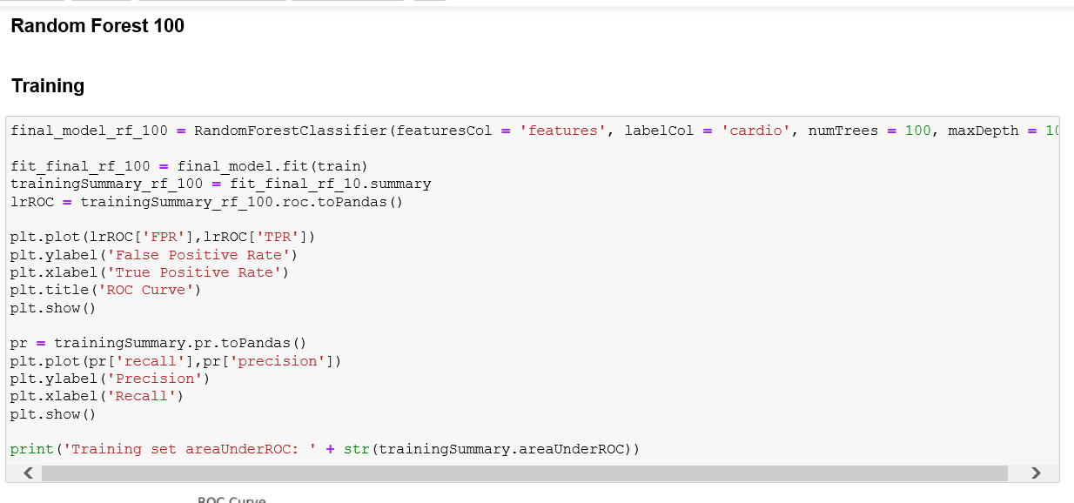

Figure 71 Random Forest 100

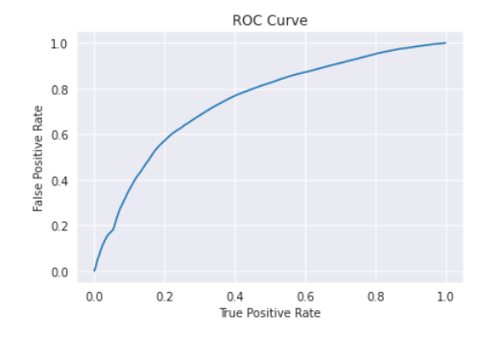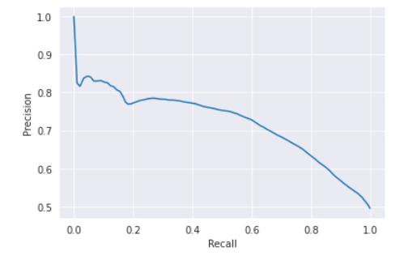

Figure 72 Training Result shown by ROC and Recall

1. **Interpretation**
   1. Study the mined patterns

From the algorithms implementing of data mining, the result could be shown for different patterns for different algorithms Logistical Regression, Decision Tree and Random Forest

Two different evaluators were used for different algorithms as ‘from pyspark.ml.evaluation import MulticlassClassificationEvaluator’ and ‘from pyspark.ml.evaluation import BinaryClassificationEvaluator’

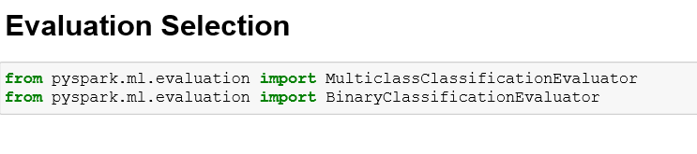

Evaluation for logistical regression:

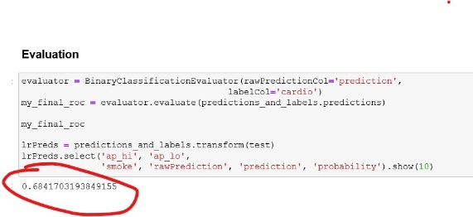

Figure 73 BinaryClassificationEvaluator

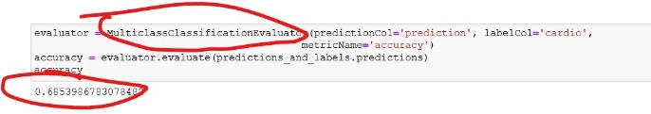

Figure 74 Result for logistical regression multipleclassification evaluation

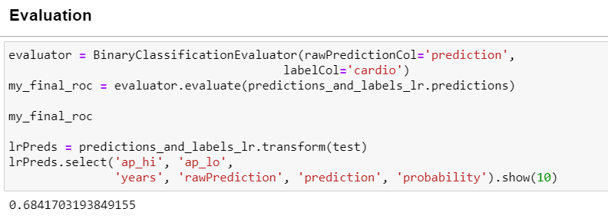

Figure 75 Data Mining Results for logistical regression.

From the results showing above, evaluation processing time for model building and computing the results. The evaluation was computed by both binary classification evaluator and multiclass classification evaluator.

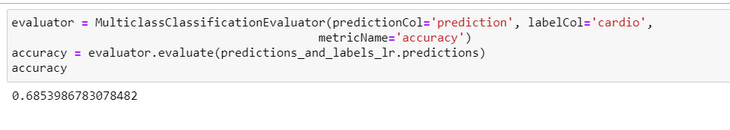

Figure 76 Multiple Class Classification Evaluator

From previous discussion, multilayers random forest has achieved highest accuracy. To evaluate the 12 features by inputting the number of max features.

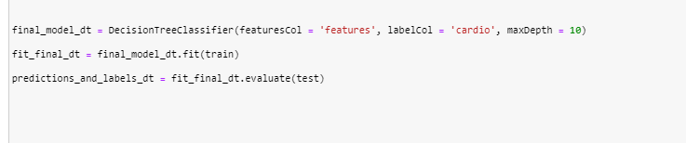

Getting the output of the importance evaluation for all the features:

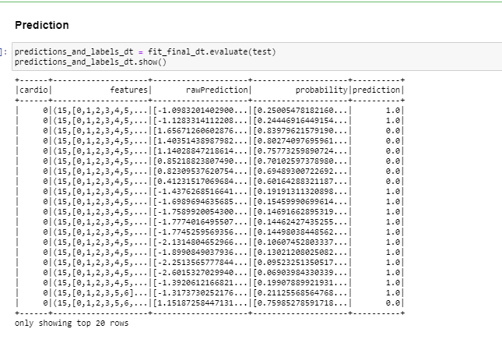

The features evaluated represents

|  |  |
| --- | --- |
| **1** | **Age** |
| **2** | **Gender** |
| **3** | **ap_hi** |
| **4** | **ap_lo** |
| **5** | **smoke** |
| **6** | **alco** |
| **7** | **active** |
| **8** | **bmi** |
| **9** | **Cholesterol_normal** |
| **10** | **Cholesterol_well_above** |
| **11** | **Gluc_normal** |
| **12** | **Gluc_well_above** |

From the factors above, the third factor is “3. ap_hi” is the most related factor from the patter. The second one is “1. age”; the third one is “8.bmi”, followed by “10. Cholesterol_well_above”.

* 1. Visualizing the Data, Results, Models and Patterns

In this session, getting back previous steps to get more exploration of dataset. Visualizing and exploring the data from several perspectives.

* + 1. Visualizing the Data Distribution of the dataset

Visualizing the height is to get whole picture for the processing and transforming in order to get formatted data in Chapter 4.

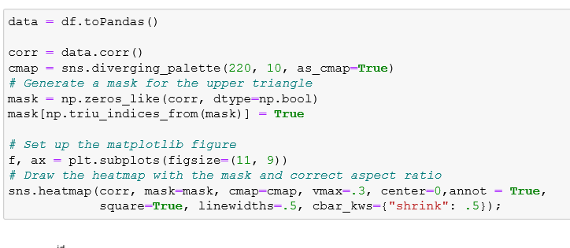

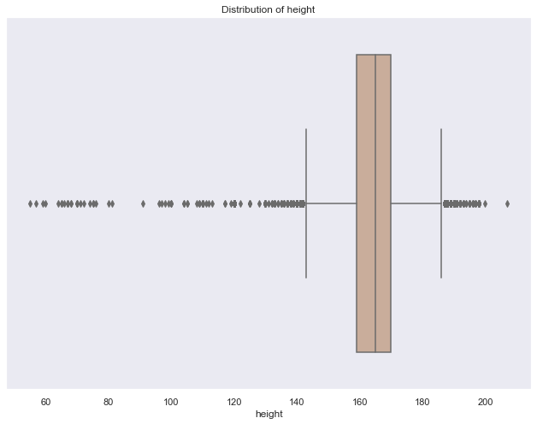

Figure 77 Height Distribution

From the figure above, there are extremes and outliers existing in the raw data set.

Then the following step is to visualize the distribution of weight. Also, there are number of extremes and outliers.

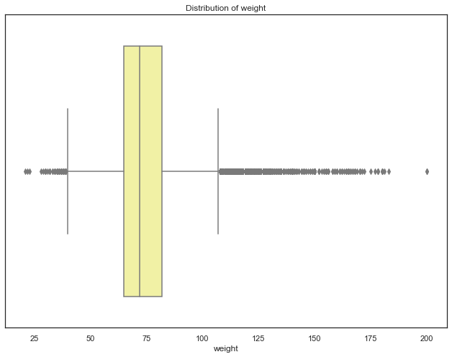

Figure 78 Distribution of Weight

Then in the pre-processing step, outliers and extremes values of “height” and “weight” were dropped.



Then the similar action was done for the new variable “bmi”

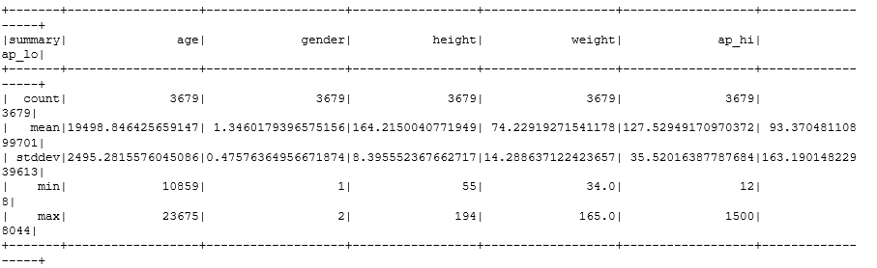

After that, the distribution of new varible “bmi” could be visualized and find out what could be done next.

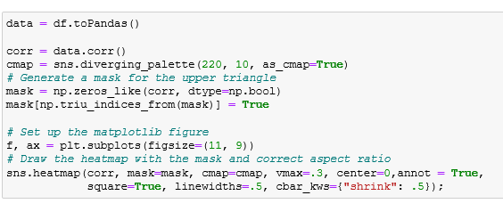

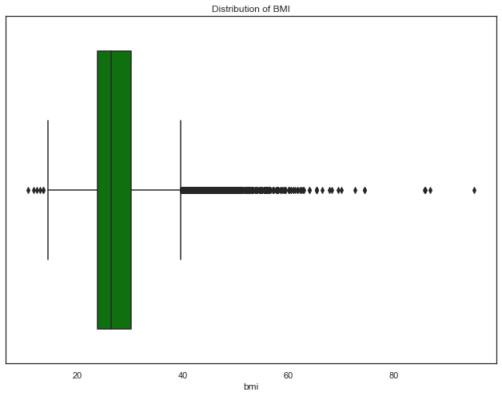

Figure 79 Distribution of add feature “bmi”

In chapter 3 and chapter 4, extremely underweight and obese data was removed because such cases seem less practical in reality. For example, there are observations with 80 cm height and 165 kgs weight which is quite impossible. Maybe it was a fake observation or typing mistake. Also, health conditions of dwarf and abnormally tall people are totally different that is why the data is not included.

Visualizing age distribution

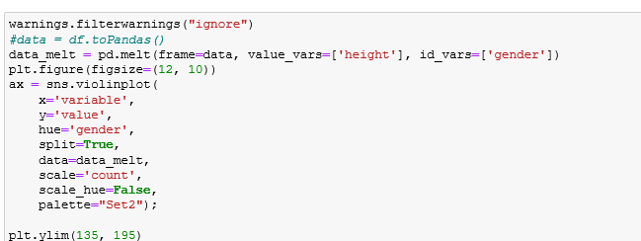

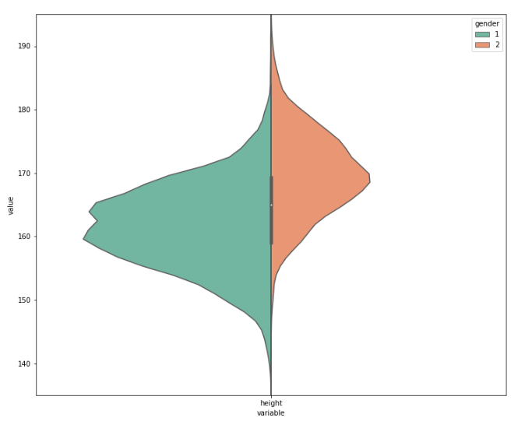

Figure 80 Age distribution

Then here comes the result:

The next step is to visualize ap_hi and ap_lo. Before beginning this step, some calculation is needed:

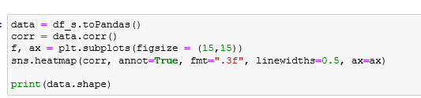

Followed by plotting:

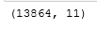

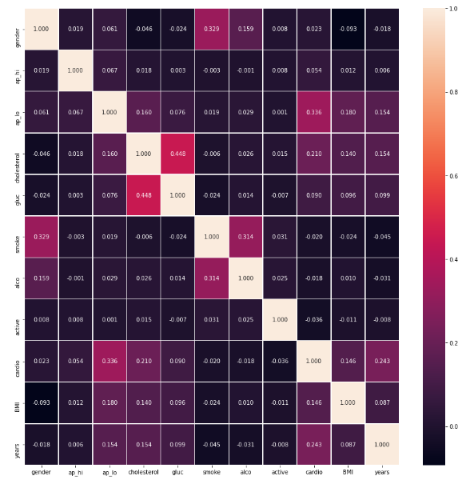

Figure 81 Cross Features distribution

* + 1. Visualizing the results, models, patterns

Implementing different features to get different accuracy. Further discussion about the

evaluation parameters will be discussed later.

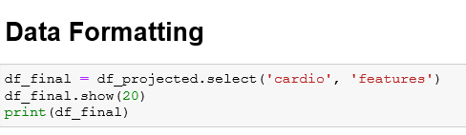

Figure 82 Final Formatting with Vectorizing

Showing 20 rows:

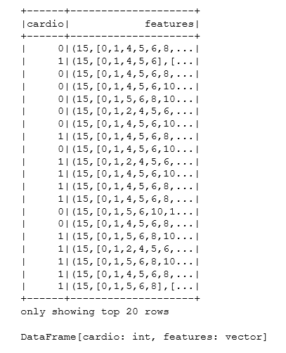

Change anther number of depth as well as features

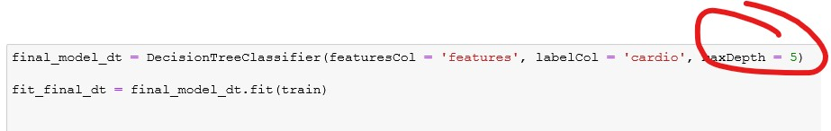

Figure 83 depth=5 with features

Returning With lower Accuracy:

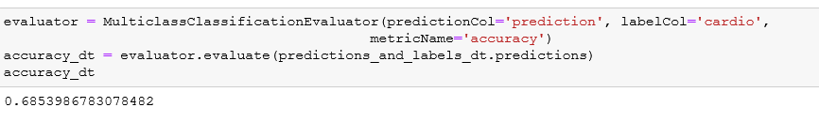

Followed by another number of depth and feature:

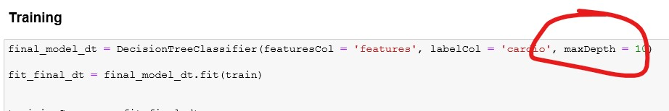

Figure 84 depth = 10

Returning with a little better accuracy:



By implementing the decision tree, followed by the tree structure:



Figure 85 A tree model with multi-layers

Similar to the Random forest when the max number of features is set to 12. Max_depth is set to 10, with number of Trees 50, returning with positive result.

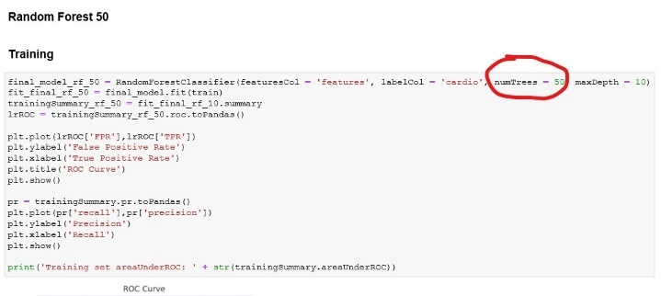

With accuracy to

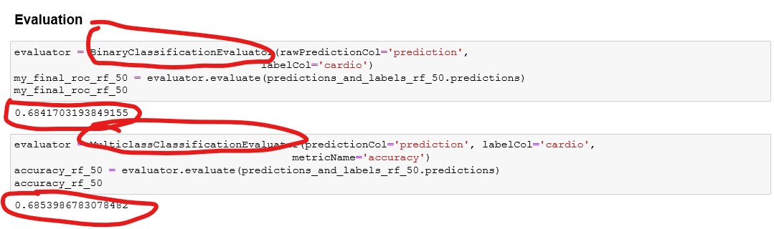

Figure 86 Evaluation by Two Evaluators

Patterns for Decision Tree:

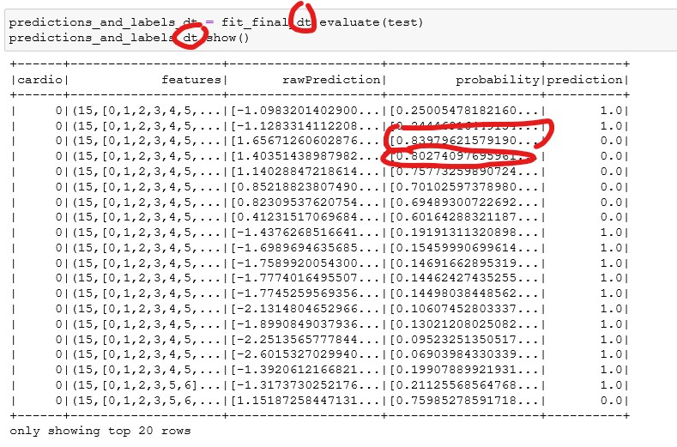

Patterns for Random Forest: take the number of 50 for trees for example:

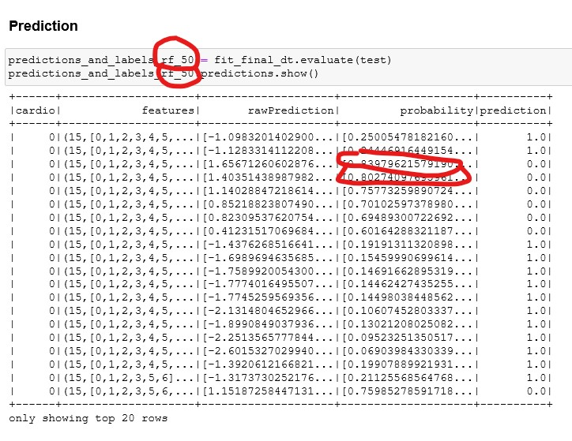

Figure 87 Random Forest 50

* 1. Interpret the Results, Models and Patterns

Different parameters set for different layers of trees with different numbers of features will develop to different patterns and models, as well as results corresponding to different dataset.

Setting parameters by tree, if depth=10, with vectorized features.

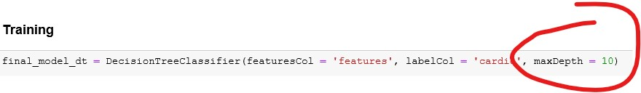

The figure of tree is

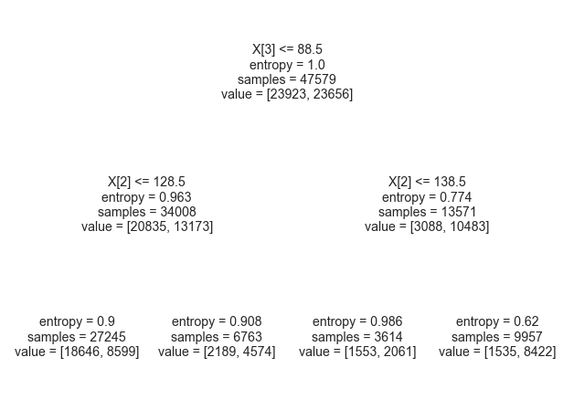

With emerging the data mining important factors showing as:

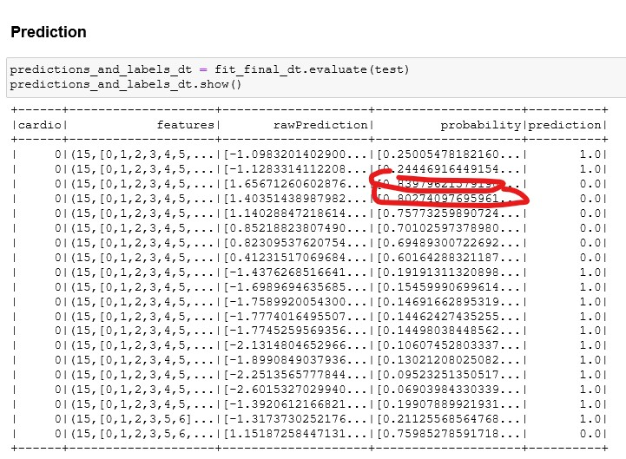

Even with totally different features selected each time:

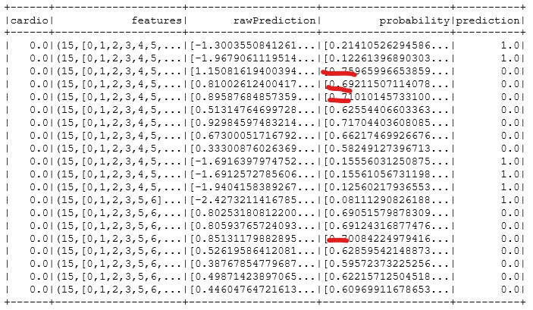

When changing the number of trees to total features, the result changes:

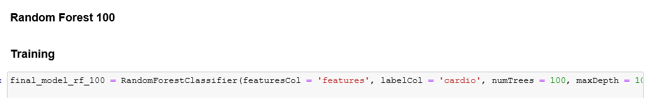

The result is stable showing below:

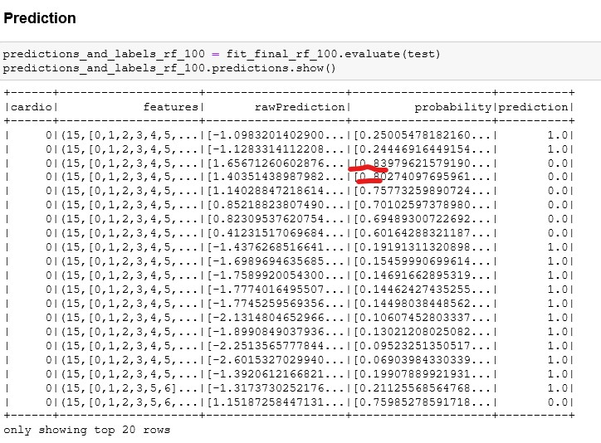

The features were mentioned in section 8.1. as the first matted thing is “ap_hi” and the second important feature is “age”.

The features evaluated represents

|  |  |
| --- | --- |
| **1** | **Age** |
| **2** | **Gender** |
| **3** | **ap_hi** |
| **4** | **ap_lo** |
| **5** | **smoke** |
| **6** | **alco** |
| **7** | **active** |
| **8** | **bmi** |
| **9** | **Cholesterol_normal** |
| **10** | **Cholesterol_well_above** |
| **11** | **Gluc_normal** |
| **12** | **Gluc_well_above** |

* 1. Assessing and Evaluating Results, Models and Patterns

**Evaluation Decision Tree**

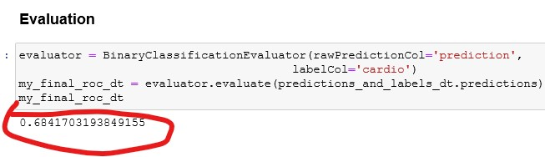

Pattern selected with accuracy and factors returned for depth of 10 and number of features equals to 12.

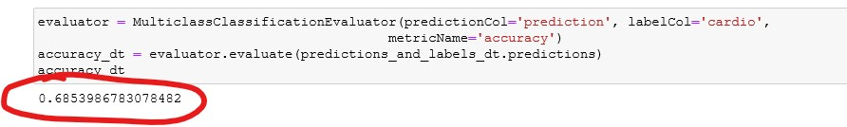

The accuracy is more than 72, pattern is for the third and first feature of the dataset.

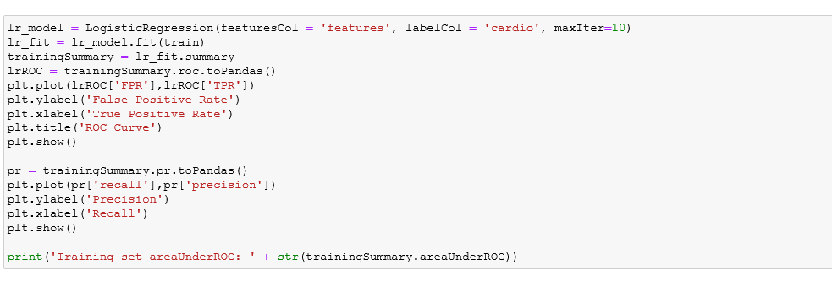

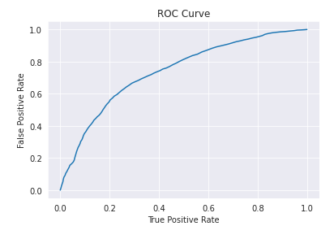

The result shows this model is pretty good tobe more than AUC 0.7

**Evaluation Random Forest**

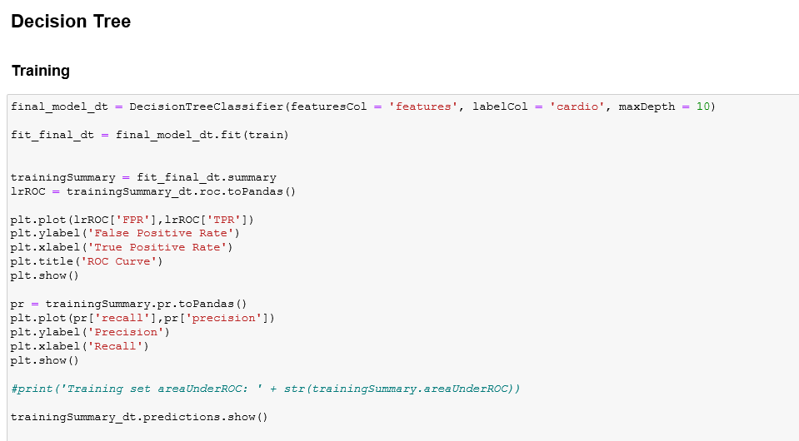

Selecting Features with accuracy for random forest:

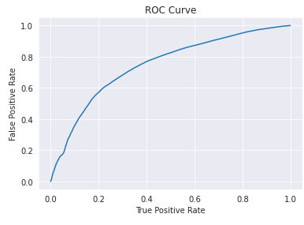

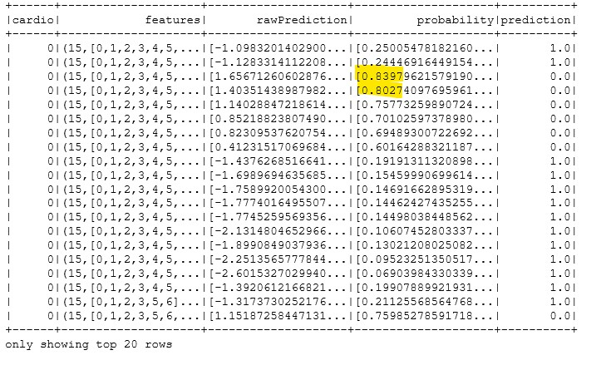

This model is better compared to random forest with higher accuracy with same pattern searched with decision tree, pattern for the first important feature is “ap_hi” and the second feature is “Age”.

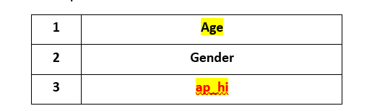

Evaluation by ROC:

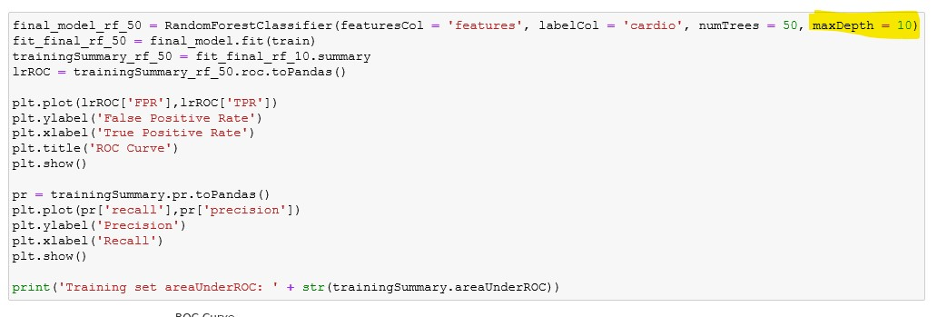

Figure 88 ROC illustration for Random forest with depth 10

The ROC show the same evaluation good performance for this model.

If there is a little bit changing existed as the depth is 6, finding out what is the difference insight

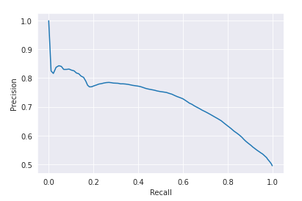

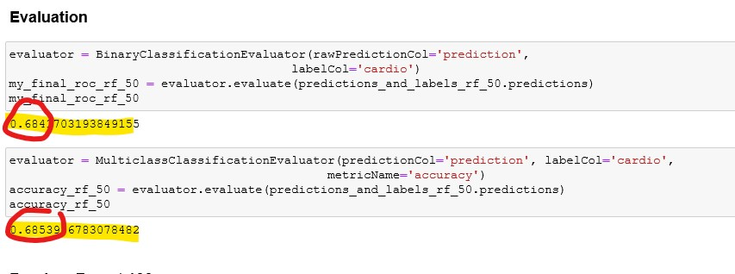

The result is roughly less than 70% with depth of 10 with number of 50 compared to with both binaryClassificationEvaluator and MulticlassClassificatoinEvaluator.

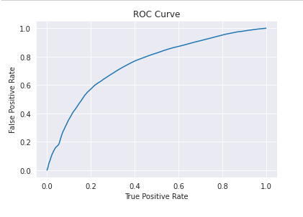

Figure 89 ROC illustration for Random forest with depth 10 with 100 Trees

When the depth changes to “2” with the same number of features, both accuracy and ROC have changed.

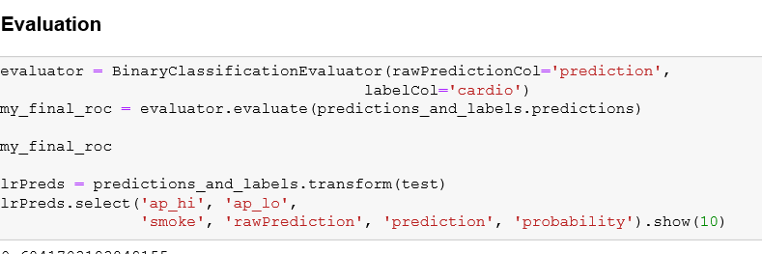

The accuracy result is roughly 72.7 compared to 73.03 with depth 10 with returning the same pattern as shown before.

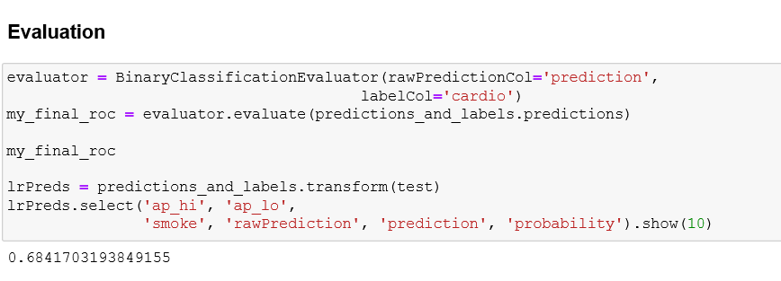 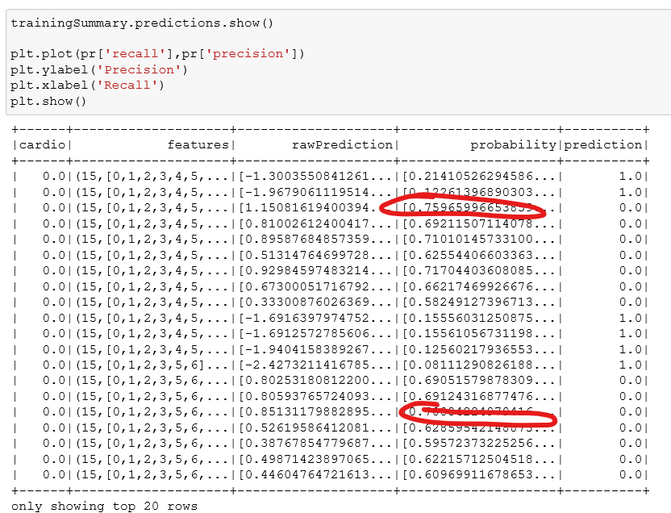

* 1. Iterations
     1. Updated chapter 4 Data Transformation

When modelling the results show

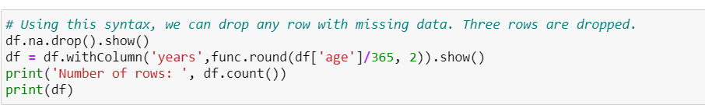

It seems the value used in model is string instead of numerical or categorical for some kind of data with name “40 s”

Searching long time, the cell in file OSAS_1,py cell 36 has changed age into sections –string—not original numerical or categorical.

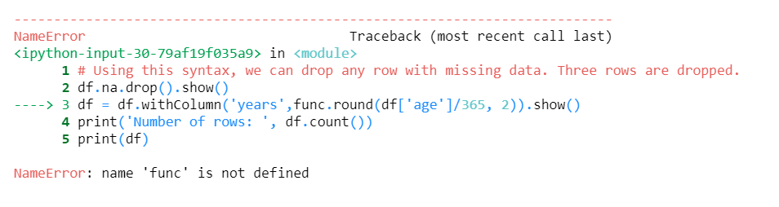

Then, the next step is to move rebuilt dataset, with totally new data cleaning, and formatting in 4.2 to do one hot encoder as normalized if possible.

* + 1. Removing Extremes, reducing features and adding new feature

When re-formatting data type for age, and re-building the final data, then more discovering was found in dataset. When height data is larger than 250, it should not be considered. And weight which is less than 20 kg is not be considered as well. The code is file 2 shows below.



As there were many outliers, both ‘height’ and ‘weight’ features were dropped by one more new feature ‘bmi’ instead.

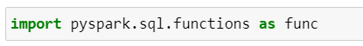

Simultaneously, the feature ‘bmi’ did the same thing to remove extremes and outliers.

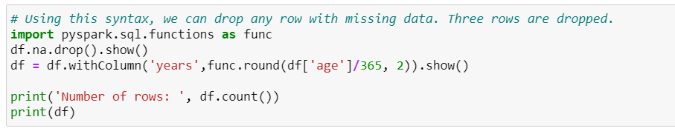

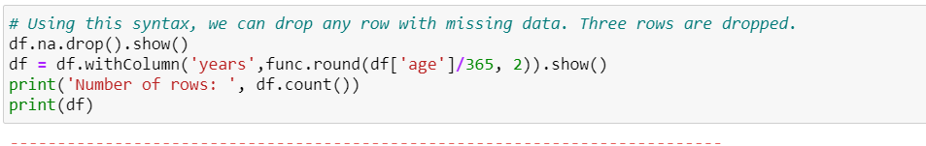

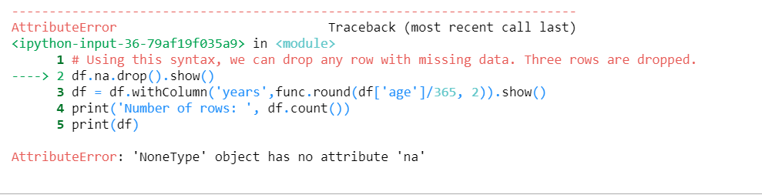

Many times lost the connect with server. When calculating, the system showed no connection with server and no attribute for `count`, `colnames`, and so on.

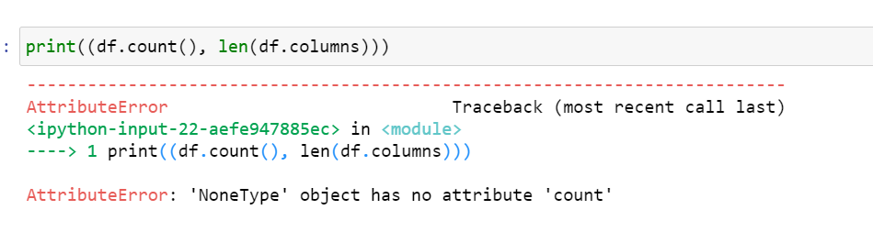

* + 1. Rebuild data type

The original data type is constructed by int, numerous, binominal, but if the data set is not process probably, it shows the string type for all variables.

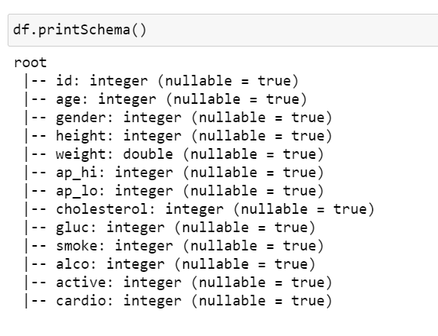

The error message shows below.

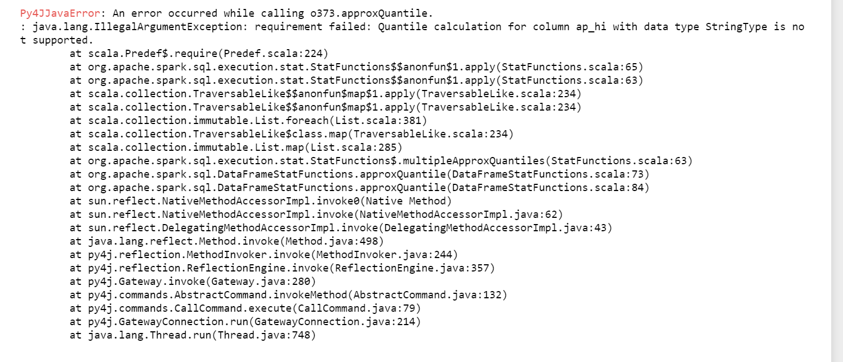

With point out the information that

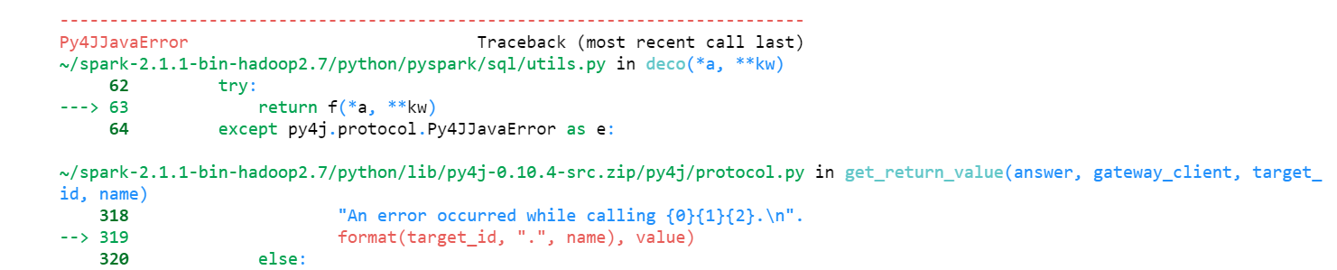

Then by changing the data set format into preprocessed way. When adding inferSchema = ‘TRUE’, the variables have changed.

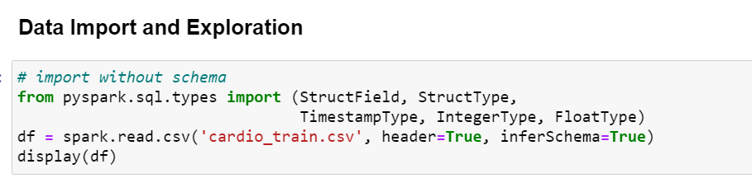



After data mining pattern developed, I rebuild three models to developed with totally preprocessing and reformatting and modelling.

When adding variable, it seems the result could work, 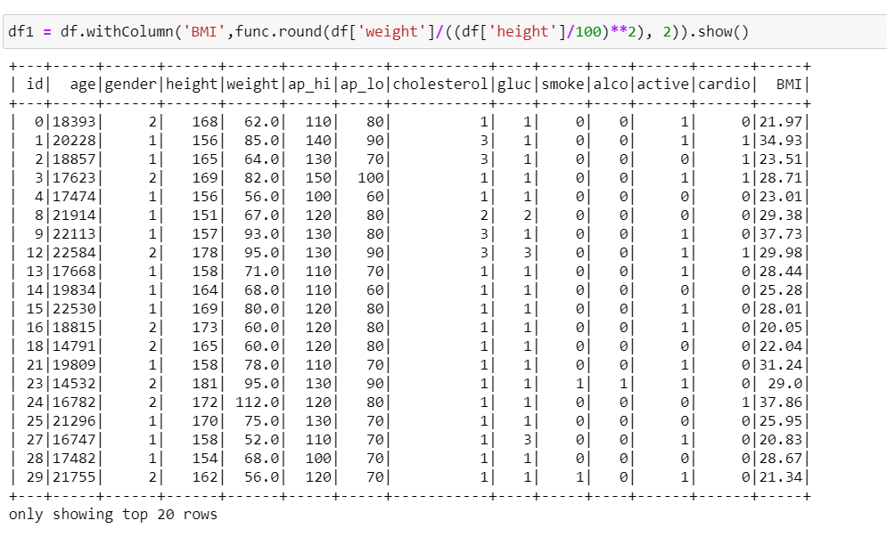

However, the result shows below, everything is lost.

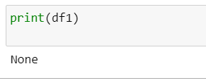

Figure 90 Adding variable debug

After debugging, the system could work by finding the `show()` was given to `df1`. So after deleting the `df1`, finally it works. So the name of data frame was changed to `df` for further process.

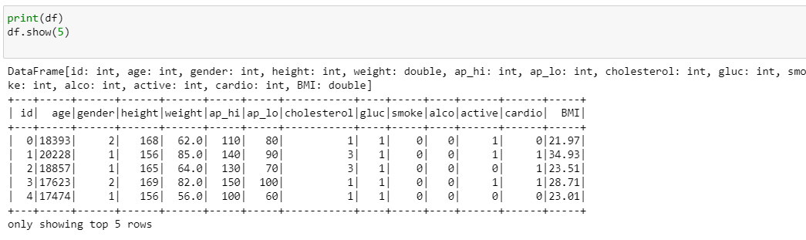

Logistical regression evaluator is not working very well.

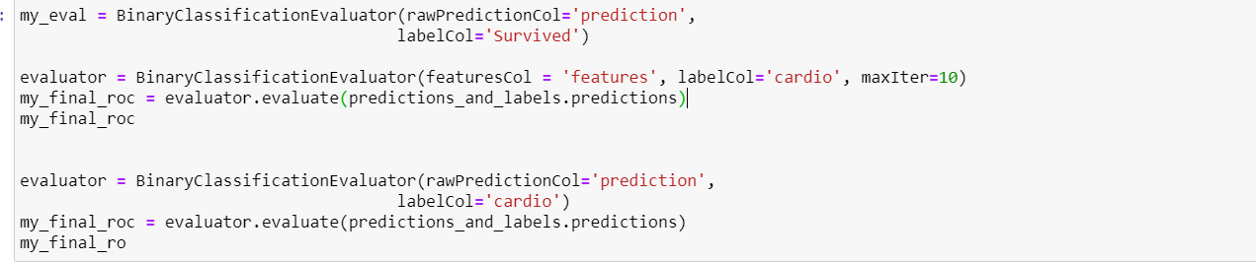

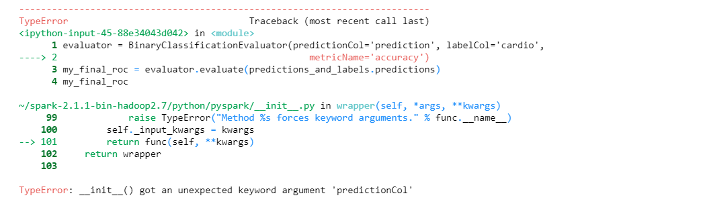

Evaluator and logistical regression have been confused.

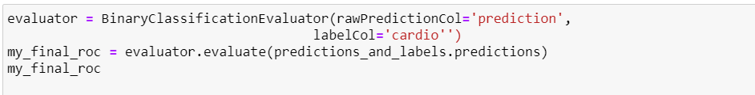

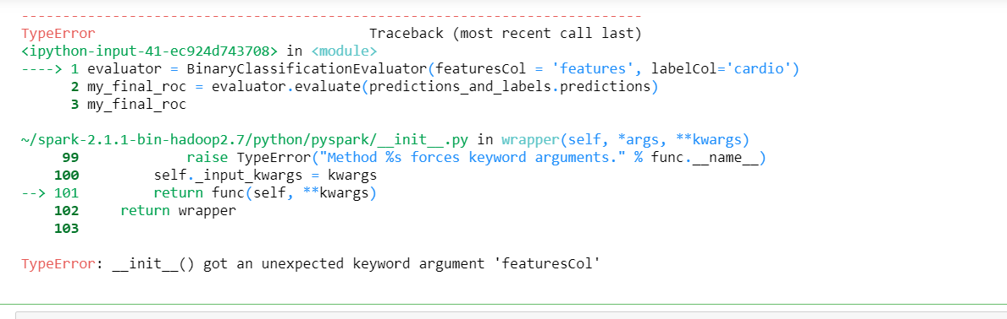

(Words Count for : 14226)

# Bibliography

(WHO), W. H. O. (2020). Cardiovascular diseases (CVDs) Key Facts.

Corporation, C. I. B. M. (2018). IBM SPSS Modeler 18.2.1 User's Guide.

Fayyad, U., Piatetsky-Shapiro, G., & Smyth, P. (1996). From data mining to knowledge discovery in databases. *AI magazine, 17*(3), 37-37.

Foundation, H. (2019). Cardiovascular disease (CVD) risk assessment and management.

Health, N. Z. M. o. (2018). cardiovascular disease risk assessment management primary care.

Papageorgiou, N. (2017). *Cardiovascular Diseases*.

Goff, D.C., et al., *2013 ACC/AHA guideline on the assessment of cardiovascular risk: a report of the American College of Cardiology/American Heart Association Task Force on Practice Guidelines.* Journal of the American College of Cardiology, 2014. **63**(25 Part B): p. 2935-2959.

Group, N.Z.G., *Assessment and management of cardiovascular risk*, Wellington:, Editor. 2003, Wellington:: Wellington:.

Health, M.o., *New Zealand Primary Care Handbook 2012.* Cardiovascular risk assessment and diabetes screening: Cardiovascular risk factor management, 2013.

Johnson, A.E., et al., *MIMIC-III, a freely accessible critical care database.* Scientific data, 2016. **3**: p. 160035.

https://mimic.physionet.org/

Walonoski, J., et al., *Synthea: An approach, method, and software mechanism for generating synthetic patients and the synthetic electronic health care record.* Journal of the American Medical Informatics Association, 2018. **25**(3): p. 230-238.

Yale, A., et al., *Generation and evaluation of privacy preserving synthetic health data.* Neurocomputing, 2020.

Pylypchuk, R., et al., *Cardiovascular disease risk prediction equations in 400 000 primary care patients in New Zealand: a derivation and validation study.* The Lancet, 2018. **391**(10133): p. 1897-1907.

Knight, J., et al., *Developing a synthetic national population to investigate the impact of different cardiovascular disease risk management strategies: A derivation and validation study.* PloS one, 2017. **12**(4).

Hsu, W., J. Warren, and P. Riddle. *Multivariate Sequential Analytics for Treatment Trajectory Forecasting*. in *Proceedings of the Australasian Computer Science Week Multiconference*. 2019.

Goodfellow, I., et al. *Generative adversarial nets*. in *Advances in neural information processing systems*. 2014.

Choi, E., et al., *Generating multi-label discrete patient records using generative adversarial networks.* arXiv preprint arXiv:1703.06490, 2017.

Esteban, C., S.L. Hyland, and G. Rätsch, *Real-valued (medical) time series generation with recurrent conditional gans.* arXiv preprint arXiv:1706.02633, 2017.

Dash, S., et al., *Synthetic Event Time Series Health Data Generation.* arXiv preprint arXiv:1911.06411, 2019.

https://datascience.foundation/sciencewhitepaper/data-mining:-models-and-methods

https://www.kaggle.com/yinyuanyinyuan/eda-cardiovascular-data/edit

**https://www.cnblogs.com/HuZihu/p/10538295.html**